

STUDENT NAME: LINET KATUNGWA

STUDENT ID: 667471

Course: apt 3065-midterm project
Instructor: Dr. Paul M. Okanda – Assoc. Professor of Information Science & Technology
Project Title: Personal Finance and Expense Tracking Web Application

DECLARATION
I hereby declare that the content of this project report is my own original work, carried out through independent research and effort. To the best of my knowledge, this work has not been submitted, in whole or in part, for academic credit in any other institution.
Signature: ……………………..Date: ……………………..
This project has been completed and submitted in partial fulfilment of the requirements for the award of the degree of Bachelor of Science in Applied Computer Technology at the United States International University – Africa.
Project Supervisor:
Prof. Paul Okanda
Signed: ……………………..Date: ……………………..

ACKNOWLEDGEMENT
This project has been a journey of learning, growth, and discovery, and I am truly grateful to everyone who walked with me along the way. First, my sincere appreciation goes to Prof. Paul Okanda, whose guidance and mentorship made all the difference. His feedback, encouragement, and patience helped me shape this project into something meaningful and practical.
I also want to thank my classmates and peers who shared ideas, asked thought-provoking questions, and encouraged me to push further. Their input gave me new perspectives and made the process less daunting and more exciting.
To my family and friends, I owe a special thank you. Your constant support, motivation, and understanding kept me going, especially during the tough moments when balancing this work with everything else seemed overwhelming.
Lastly, I am thankful to United States International University – Africa (USIU-Africa) for providing not just resources, but also an environment that inspires innovation and creativity. This project would not have been possible without the strong foundation the institution has given me.

ABSTRACT
Managing personal finances has become increasingly challenging in today’s fast-paced world, where expenses accumulate quickly and budgeting often feels overwhelming. Many people still rely on manual methods such as notebooks, spreadsheets, or scattered mobile notes to track their money. These approaches are time-consuming, prone to errors, and lack the structure needed to give users a clear, real-time picture of their financial health. As a result, overspending, missed savings opportunities, and financial stress are common.
This project proposes the development of Money Mate, a centralized and user-friendly personal finance and expense tracking web application designed to help individuals take full control of their money. Unlike traditional methods, Money Mate digitizes and streamlines financial management by offering an intuitive platform where users can log income, categorize expenses, set savings goals, and monitor their budget in real time.
The system introduces practical features such as automated expense tracking through categorized entries, interactive dashboards with visual insights, budget alerts to prevent overspending, and personalized savings recommendations. A secure login ensures that each user’s data is private, while the dashboard provides clear reports that make money management less intimidating and more empowering. By simplifying financial tracking into easy-to-understand visuals and notifications, the platform not only reduces errors but also promotes smarter decision-making.
Built on modern web technologies with scalability and security in mind, Money Mate offers a reliable and adaptable solution for anyone seeking to improve financial discipline. Ultimately, this project aims to transform the way individuals interact with their finances—turning budgeting from a stressful chore into a manageable, transparent, and even motivating daily habit.

TABLE OF CONTENTS
DECLARATION ii
ACKNOWLEDGEMENT iii
ABSTRACT iv
CHAPTER 1: INTRODUCTION 1
1.1 Background of Personal Finance Management Systems 2
1.2 Problem Statement 2
1.3 Conclusion 3
CHAPTER 2: LITERATURE REVIEW 5
2.1 Overview 5
2.2 Global Scale 6
2.2.1 YNAB (You Need A Budget) 7
2.2.2 Mint 9
2.3 Regional Scale 10
2.3.1 Spendee (ASIA) 11
2.3.2 Mobills 13
2.4 Local Scale (Kenya) 16
2.4.1 CountPesa 16
2.4.2 Pesatrail 18
2.5 Strengths and Weaknesses of the Selected Systems 20
2.6 Conclusion 23
CHAPTER THREE: AIMS AND OBJECTIVE 25
3.1 General Aims and Objectives 25
3.2 Specific Aims and Objectives 26
3.3 Conclusion 26
CHAPTER FOUR: PROPOSED PROJECT 28
4.1 Project Phases 29
4.1.1 Phase One: Research, Requirements Gathering, and System Design 29
i. Research 29
iii. Proposal 30
iv. System Design 31
4.1.2 Phase Two: System Coding 31
ii. System Frontend 32
iii. System Backend 32
iv. Database 33
v. System Integration 33
vi. Core Functionality Implementation 33
4.1.3 Phase Three: Testing, Documentation, and Presentation 34
i. Software Testing and Evaluation 34
ii. Project Write-Up 35
iii. Final Presentation and Submission of Report 35
4.2.1 Phase One: Research, Requirements Gathering, and System Design 36
ii. Requirements Gathering 38
iii. Proposal Development 38
iv. System Design 39
iv. System Design 39
4.2.2 Phase Two: System Implementation 41
i. Frontend Development 41
4.3 Gantt Chart 44
4.4 Requirements 46
Dependencies 47
Milestones 47
4.4.1 Software Requirements 48
4.4.2 Hardware Requirements 48
4.4.3 Server Requirements 49
4.4.4 Budget Requirements 49
CHAPTER FIVE: SYSTEM ARCHITECTURE AND DESIGN 51
5.1 Introduction 51
5.2 System Models 51
5.2.1 System Architecture Overview 52
5.2.2 Use Case Diagram 53
5.2.3 Flowchart 54
5.2.4 Entity Relationship Diagram 56
5.2.5 Data Flow Diagram 57
5.2.7 Activity Diagram 63
5.2.8 Sequence Diagram 65
5.2.9 Wireframe Diagram 67

CHAPTER 1: INTRODUCTION
Money is something we all deal with every single day, yet managing it well remains a huge challenge for many people. Often, we spend without realizing how much is leaving our pockets. At the end of the week or month, we wonder where our money went. Small expenses like daily snacks, transport, or impulse shopping add up, but because they are not tracked, they easily get forgotten.
This lack of awareness leads to overspending, missed bills, and little or no savings. For students, this might mean running out of pocket money halfway through the semester. For young professionals, it can mean living pay check to pay check without building savings. Even families struggle when there is no clear record of where money is going.
Although there are existing financial management tools, many are too complicated, too expensive, or not tailored for everyday users. Some require advanced knowledge of finance, while others are built for large organizations rather than individuals. This creates a gap ordinary people need a simple, accessible way to track their income and expenses.
My project addresses this problem by developing a Personal Finance and Expense Tracking Web Application. The system is designed to make financial management easy and practical. Users will be able to record their income and expenses, categorize their spending, set personal budgets, and receive reminders for upcoming bills. The platform also provides visual reports in the form of charts and graphs, giving users a clear picture of their financial habits.
In short, this project is about empowering individuals to take control of their money. By using the system, users can avoid overspending, make smarter financial decisions, and build better financial discipline over time.
Beyond just tracking numbers, this project also recognizes the psychological side of money management. Many people avoid looking at their expenses because it feels overwhelming or stressful. By presenting financial data in a simple and visual way, the system removes that fear and makes money management approachable. Instead of seeing finance as a burden, users can see it as a tool for planning their future whether that’s saving for school fees, investing in a business idea, or just making sure there’s enough left at the end of the month

1.1 Background of Personal Finance Management Systems
Managing money is something everyone has to do, whether it’s a student budgeting their pocket money, a young professional paying bill, or a family planning household expense. For many years, people relied on very simple methods writing down expenses in notebooks, keeping receipts, or just trying to remember what they spent. While these manual methods worked for some, they were often inconsistent, time-consuming, and easy to forget [Smith, 2018].
As technology grew, spreadsheets like Microsoft Excel gave people a better way to record and calculate their finances. Later, dedicated personal finance tools and mobile apps such as Mint and YNAB became popular, allowing users to track expenses, set budgets, and view reports instantly [Johnson, 2019]. These tools introduced convenience and automation, making money management more accessible.
However, despite these improvements, a lot of people still struggle with financial discipline. Many existing tools are designed for users in developed countries and expect integration with international banking systems. Others are filled with advanced features that feel overwhelming for everyday users who only want something simple [Lee & Wang, 2020]. Cost is also a barrier, as some apps require subscriptions that not everyone can afford [Brown, 2021].
This creates a gap ordinary people, especially students and families in developing regions, need a simple, affordable, and user-friendly system to track income, monitor expenses, and set budgets. Our project, the Personal Finance and Expense Tracking Web App, is designed to fill this gap. It focuses on the basics of money management while keeping things clear, practical, and easy to use.

1.2 Problem Statement
Despite the growth of digital tools and financial apps, overspending and poor financial management remain common problems. Many individuals do not have a clear picture of where their money goes on a daily basis. Small but frequent expenses such as transport, snacks, or impulse shopping often go unnoticed, but when accumulated, they drain a significant portion of income [Smith, 2018]. Without proper tracking, people end up living pay check to pay check, unable to save, and often stressed when unexpected expenses arise.
Existing personal finance applications attempt to solve this, but most of them fall short for ordinary users. Some are too complex, filled with features that require advanced financial knowledge to use effectively [Lee & Wang, 2020]. Others are built primarily for users in developed markets, requiring integration with international banking systems that are not accessible in many regions. Subscription costs also make certain tools unaffordable for students and low-income earners [Brown, 2021]. As a result, the very groups that need financial guidance the most often remain underserved.
The lack of a simple, affordable, and user-friendly solution leaves people vulnerable to overspending and poor money management. This not only affects their ability to meet daily needs but also prevents long-term financial stability. There is therefore a clear need for a web-based platform that focuses on the basics: recording income, categorizing expenses, setting budgets, and providing reminders. Such a system can empower individuals to develop financial discipline, make informed decisions, and ultimately avoid the cycle of uncontrolled spending.

1.3 Conclusion
Money touches every part of life, yet many people continue to struggle with how they handle it. Students often find themselves out of cash halfway through the semester, young professionals frequently live pay check to pay check, and families sometimes cannot explain where most of their income has gone at the end of the month. These challenges are not always because people lack enough money, but because they lack clear and consistent ways to manage it. Overspending usually happens quietly, through small daily expenses that seem harmless but quickly add up.
Traditional methods like using notebooks, diaries, or memory are unreliable. People forget to record transactions, lose track of receipts, or simply abandon the process when it feels like a burden. On the other hand, existing personal finance apps promise solutions but are often designed for a different audience. Many are overloaded with features that overwhelm the average user. Others demand subscriptions or require linking with international banking systems, making them inaccessible to students, low-income earners, or individuals in regions where such integrations are not available.
This creates a gap that is too large to ignore. People need a financial management tool that is simple, affordable, and user-friendly that focuses on the basics without unnecessary complexity. A system that allows users to record income and expenses, categorize their spending, set personal budgets, and receive reminders for upcoming bills can make a meaningful difference. When presented in a clear, visual, and easy-to-understand format, financial data stops being intimidating and instead becomes empowering.
The proposed Personal Finance and Expense Tracking Web Application is designed to meet this need. By helping users track their money more effectively, it addresses the root causes of overspending and promotes better financial discipline. Over time, this kind of tool can reduce stress, encourage savings, and support long-term financial stability. In essence, this project is not just about building a system; it is about giving people the confidence and clarity to take control of their financial lives.

CHAPTER 2: LITERATURE REVIEW
This chapter explores the existing body of knowledge related to personal finance management and expense tracking systems, with an emphasis on their application in households, educational institutions, workplaces, and global financial markets. As the cases of overspending, poor budgeting, and financial stress continue to rise across various sectors, individuals and organizations are increasingly turning to digital solutions to manage money more efficiently.
The review examines how technological innovations such as cloud computing, mobile integration, artificial intelligence (AI), and web-based dashboards have been utilized to streamline processes of expense tracking, budget planning, financial reporting, and personalized reminders. These advancements have contributed significantly to reducing manual effort, improving financial awareness, and enhancing the speed and accuracy of decision-making in money management.
By comparing global, regional, and local implementations, this chapter identifies the strengths and limitations of both manual and digital systems. While global systems such as Mint, YNAB, and Fast Budget benefit from sophisticated automation and integration with banks, many regional and local solutions particularly within Africa still rely heavily on manual record-keeping, basic spreadsheets, or physical receipts. This often leads to inefficiencies, lack of real-time insights, and lost opportunities to save money.
The insights from this review will help shape a more effective and scalable solution in the form of MoneyMate, ensuring the proposed system aligns with current best practices while addressing local needs and constraints. By focusing on simplicity, localization, and accessibility, MoneyMate aims to empower users to take control of their money in ways that feel intuitive, motivating, and culturally relevant.

2.1 Overview
Personal finance and expense management systems have gradually evolved from traditional manual methods, such as handwritten notebooks and spreadsheets, to advanced digital platforms. These modern systems leverage technologies like cloud computing, web applications, and artificial intelligence to provide real-time expense tracking, smart budget planning, and personalized financial insights. Such advancements have significantly improved the way individuals understand their money, enabling them to save more, avoid overspending, and make informed financial decisions.
Despite these technological strides, challenges persist, particularly in developing regions. Issues such as limited access to digital tools, low financial literacy, and affordability barriers hinder the effective adoption of personal finance platforms. For instance, many people in Kenya and similar contexts still rely heavily on manual methods such as jotting expenses in a notebook or trying to recall spending patterns from memory. The lack of localized solutions such as those that support local currencies and daily expense categories like matatu fares or airtime also reduces the effectiveness of global finance apps in these regions.
MoneyMate is designed to bridge this gap by offering a simple, web-based, and locally relevant platform that empowers users to track expenses, set budgets, and receive timely reminders. By combining ease of use with cultural and financial relevance, the system aims to make financial management accessible and motivating for a wider audience.

2.2 Global Scale
A global scale refers to something that happens, operates, or has an impact across the entire world rather than being limited to a specific country, region, or community.
Globally, personal finance and expense tracking systems have gained significant adoption across diverse sectors, including households, educational institutions, and business organizations. These systems are designed to streamline the process of recording income, tracking expenses, and planning budgets by digitizing workflows and enhancing user experience. Their primary goal is to empower individuals and families to make informed financial decisions, build savings, and avoid unnecessary debt.
Notable global platforms include Mint, YNAB (You Need A Budget), and PocketGuard, which utilize technologies such as cloud synchronization, mobile applications, artificial intelligence, and financial analytics to provide users with real-time insights into their spending habits. These platforms often integrate directly with banks and financial institutions, automatically categorizing expenses and offering predictive budgeting suggestions.
While these systems have transformed financial management in many developed countries, they are often region-specific and cater to markets with established digital banking infrastructures. Their reliance on bank integrations and premium subscription models makes them less accessible to users in developing regions, where banking penetration may be lower and affordability is a concern.

2.2.1 YNAB (You Need A Budget)
You Need A Budget, commonly known as YNAB, is one of the most influential global platforms in the personal finance management space. Unlike many applications that simply track spending, YNAB is built on a philosophy that teaches users to take control of their money by actively assigning every unit of income a specific purpose. This principle, often summarized as “give every dollar a job,” transforms budgeting from a passive act of record-keeping into a proactive strategy for financial planning. By encouraging users to allocate income immediately into categories such as rent, groceries, transportation, and savings, YNAB fosters discipline and long-term awareness of financial priorities.
The application is designed to provide more than just a digital ledger. It helps users plan for both predictable and unexpected expenses, encouraging them to embrace what it calls “true expenses.” This means setting aside money for future obligations such as school fees, medical bills, or even annual subscriptions, which many people tend to overlook until the cost suddenly arises. In addition, YNAB promotes flexibility through its philosophy of “rolling with the punches,” acknowledging that real life rarely goes as planned. If users overspend in one category, they are guided to adjust their budgets rather than feeling like they have failed. Over time, YNAB also teaches the practice of “aging money,” where the goal is to spend only last month’s income instead of relying on current earnings, creating a buffer that leads to greater financial security.
What makes YNAB particularly powerful is its ability to shift the mindset of its users. Many people report that the platform not only helps them track money but also reshapes how they think about financial discipline. It is often credited with helping individuals and families break free from debt and create sustainable savings habits. The system includes workshops, guides, and an active online community that provides educational support, making YNAB feel like more than an app it becomes a financial coach.
Despite its strengths, YNAB faces several challenges. The most significant barrier is its cost, as the platform requires a monthly subscription that can be prohibitive for users in lower-income regions. Its design also assumes a certain level of financial literacy and discipline, which may intimidate beginners who simply want a straightforward way to see where their money is going. For users in developing countries, its heavy reliance on credit cards and bank account integrations also limits accessibility, since not all users operate primarily within formal banking systems. Nonetheless, YNAB has set a global standard for proactive budgeting and demonstrates the transformative potential of digital tools in shaping healthy financial behaviours.
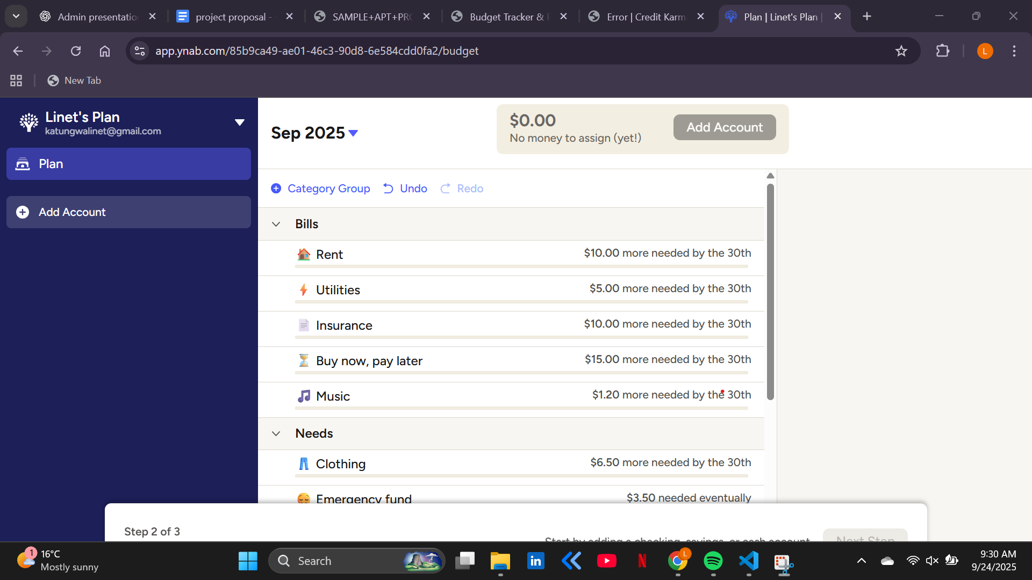Figure 1: YNAB budgeting interface(source YNAB)
Figure 1 illustrates the budgeting interface of You Need A Budget (YNAB), specifically the user’s monthly plan for September 2025. At the top of the page, the system indicates that there is currently “$0.00 – No money to assign (yet!)”, meaning income has not yet been allocated across expense categories. This reflects YNAB’s core philosophy of “giving every dollar a job.” Instead of passively recording spending, the app requires users to deliberately assign money to bills, savings, or goals as soon as income is received. On the left-hand panel, the profile is customized as “Linet’s Plan”, reinforcing the personal and user-centered nature of the system. Users can also choose to link accounts or add them manually, which makes it possible to track not just cash but also digital accounts like bank balances or credit cards.
In the central budgeting panel, we see how YNAB organizes money into categories such as Bills (Rent, Utilities, Insurance, Buy Now Pay Later, Music) and Needs (Clothing, Emergency Fund). Each entry displays how much more money is needed before the month’s end — for example, Rent requires $10 more, while Utilities still needs $5. This step-by-step allocation creates clarity and accountability, ensuring users stay aware of gaps in their planning. Unlike traditional expense trackers that simply show spending after it happens, YNAB provides a forward-looking financial strategy, reminding users of both present and future obligations. The design highlights YNAB’s strength as more than just an app: it acts as a financial mentor, encouraging proactive decisions, building emergency cushions, and promoting healthier money habits. By turning financial responsibilities into clear, achievable steps, YNAB reduces stress and empowers individuals to take intentional control of their finances.

2.2.2 Mint
Mint is one of the most well-known personal finance and budget tracking applications worldwide. It was launched in 2006 and later acquired by Intuit, the company behind TurboTax and QuickBooks. Over the years, Mint has gained a reputation as a “one-stop shop” for personal financial management, serving millions of users across the globe.
What makes Mint powerful is how it automatically pulls together all your financial information into one dashboard. By securely linking to your bank accounts, credit cards, loans, and investments, it gives you a real-time overview of your financial health without the hassle of entering transactions manually. The system then categorizes spending (like groceries, rent, entertainment, transport) and shows you exactly where your money goes. This automation saves time and makes budgeting feel effortless.
Mint also helps users set up personalized budgets. For example, you can decide how much you want to spend on dining out each month, and Mint will alert you if you’re about to overshoot. It doesn’t just stop at tracking; it also provides bill reminders, tracks credit scores, and offers financial tips tailored to your spending habits. The app is designed to make finances less intimidating by turning raw numbers into colourful charts and clear insights that are easy to understand.
Globally, Mint is seen as a pioneer because it combined financial aggregation, budgeting, and credit monitoring in a free, user-friendly web app. Its success lies in giving ordinary people the tools once reserved for accountants or financial experts—making money management accessible, transparent, and even motivating.
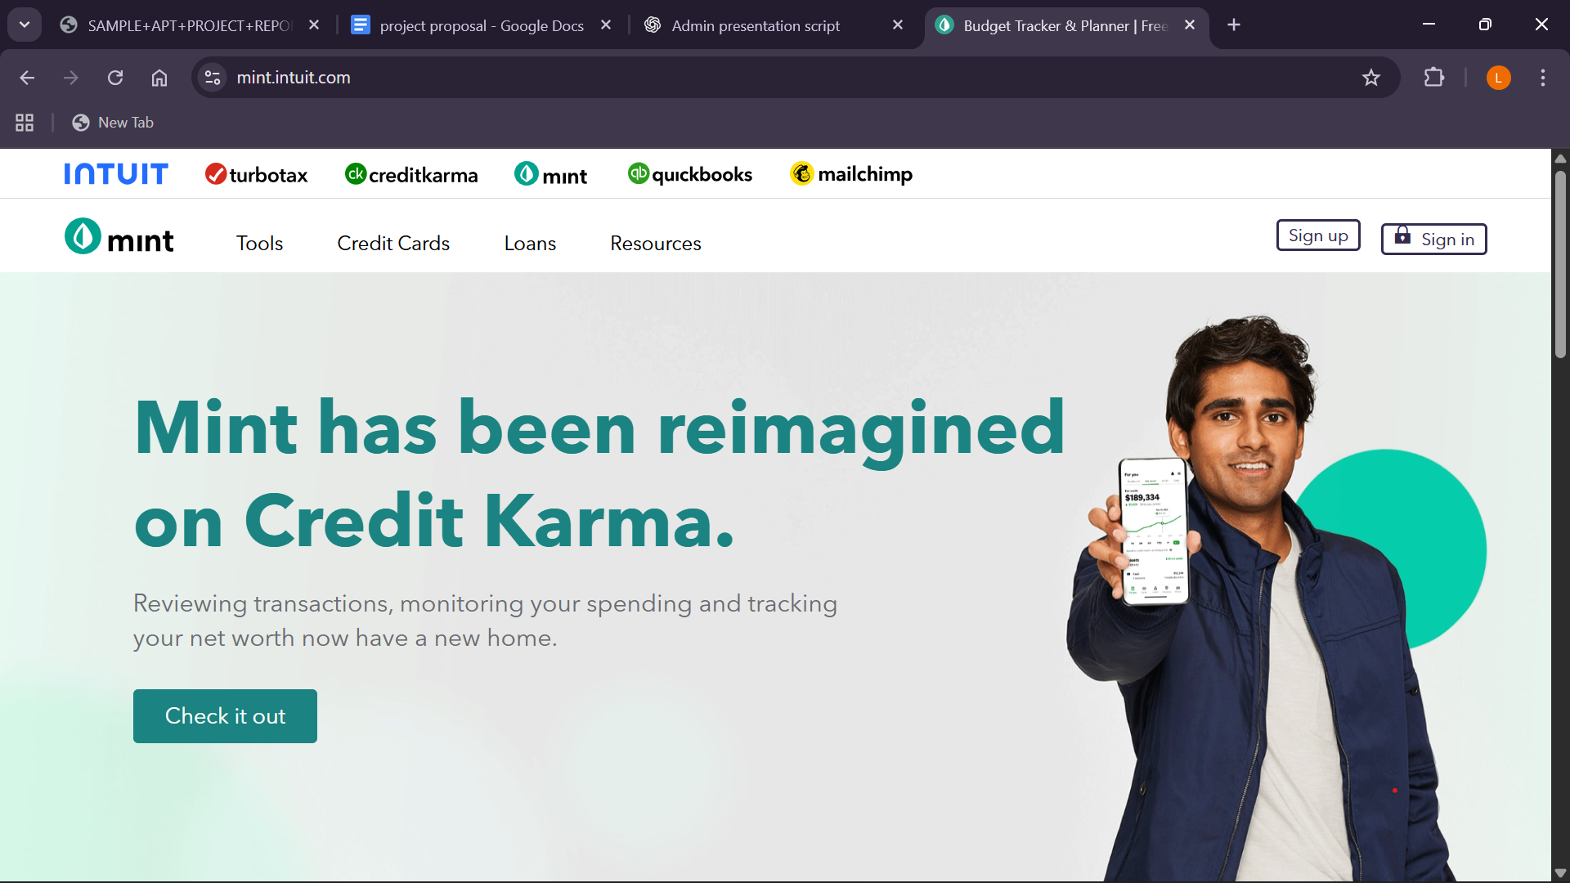Figure 2:user interface and login interface (source: Mint)
Figure 2 illustrates Mint’s transition into Credit Karma, showing how one of the world’s most popular budgeting tools has evolved over time. Once a standalone app helping millions manage their day-to-day spending, Mint has now been reimagined and folded into Credit Karma to offer a broader suite of financial services. This shift highlights how financial apps must constantly adapt to changing user needs, market demands, and the growing expectation of convenience.
For MoneyMate, this evolution carries important lessons. Unlike Mint, which broadened its scope into credit monitoring and lending, MoneyMate can remain focused on what users in its target audience need most simple, intuitive, and localized expense tracking. At the same time, Mint’s journey reminds us that growth is inevitable; users will expect new features such as savings goals, reminders, or financial tips as they continue using the app. The takeaway for MoneyMate is to start small and user-centered, but build in a way that leaves room for scalability and adaptation, ensuring it stays relevant and valuable over time

2.3 Regional Scale
A regional scale refers to something that operates within or affects a specific geographic area, such as a group of neighbouring countries, a region within a country, or a continent rather than the entire world.
Across Africa, the adoption of personal finance and expense tracking systems is still in its early stages compared to global markets. Many individuals and households continue to rely on manual methods, such as keeping handwritten notes, storing receipts, or using simple spreadsheets, to monitor their income and spending. While these methods provide some level of financial awareness, they are often inconsistent, time-consuming, and prone to errors. For most people, the lack of real-time insights makes it difficult to fully understand where their money goes or to develop sustainable savings habits.
In recent years, however, the rise of mobile technology and mobile money services such as M-Pesa in Kenya, MTN Mobile Money in Uganda, and Airtel Money across East Africa has significantly transformed the financial landscape. These platforms have enabled millions of unbanked individuals to access financial services, make transactions, and store value digitally. Some regional fintech companies have built on this foundation to introduce budgeting and expense tracking features, often bundled within banking or loan apps. For example, certain Kenyan digital lenders provide users with expense summaries and reminders alongside their credit services. While these features are useful, they remain limited in scope and are rarely designed with the primary goal of empowering personal budgeting or long-term financial planning.
Despite these technological advancements, challenges remain. Many existing systems in Africa face barriers such as low financial literacy, lack of localization in global apps, limited internet access, and affordability issues. For instance, while platforms like Mint or YNAB thrive in the U.S., they are practically inaccessible to many African users because of their reliance on bank integrations and monthly subscriptions. Even when regional apps exist, they often fail to provide user-friendly dashboards or culturally relevant categories (like fare, airtime, or food shopping), forcing users to adapt to systems not built for their realities.
This gap presents a unique opportunity for localized solutions like MoneyMate, which is specifically tailored to the African context. By being web-based, affordable, and customizable to local currencies and spending categories, MoneyMate seeks to meet users where they are. Instead of overwhelming them with technical complexity, it provides simple, visual, and empowering tools that encourage better financial decisions. In doing so, it addresses both the digital divide and the cultural gap in financial management solutions currently available in the region.

2.3.1 Spendee (ASIA)
Spendee is a popular global budgeting and expense-tracking application that has gained traction across different regions, including parts of Asia. The app is designed to give users a clear picture of their financial habits by combining manual entry with automatic transaction tracking in supported regions. Through its intuitive interface, users can categorize their income and expenses, set budgets for specific categories such as groceries or entertainment, and receive alerts when they are close to exceeding those limits. One of Spendee’s most appreciated features is its ability to create multiple wallets and budgets, allowing individuals to track spending across different income streams or manage shared finances within families or groups.
A major strength of Spendee lies in its visual design. By presenting financial data in colorful charts and graphs, the app transforms raw numbers into insights that are easy to understand at a glance. This visual clarity makes financial management less overwhelming, encouraging consistent use even among those who are not naturally inclined toward budgeting. In addition, features such as bill reminders and shared wallets make it adaptable to different lifestyles, especially in regions where household or communal budgeting is common. However, some users in Asia have noted challenges such as limited local bank integrations and the higher cost of premium features, which may restrict access for individuals who rely on more affordable tools.
For a project like MoneyMate, Spendee offers valuable lessons. First, it demonstrates the importance of making financial management both simple and visually engaging, so users are not discouraged by complex spreadsheets or technical jargon. Second, the success of shared and multiple wallets shows the need to design for real-life financial situations, where people may juggle different income sources or manage money collectively. Finally, Spendee’s use of reminders and spending alerts illustrates the role of gentle nudges in promoting healthier financial behaviour. At the same time, the limitations reported by its users highlight opportunities for MoneyMate to provide a more localized, affordable, and user-centered solution tailored to its target market
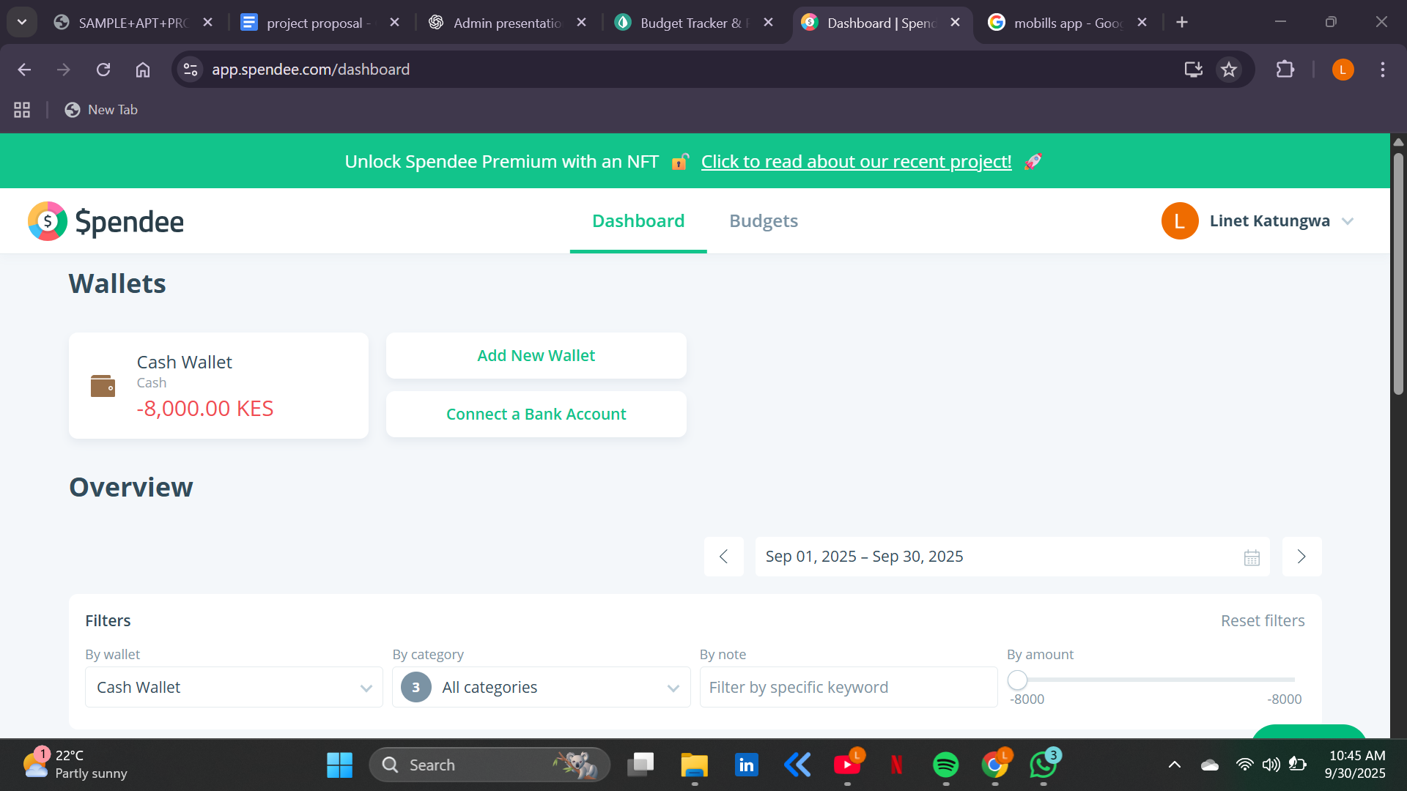Figure 3: spendee dashboard (source: spendee)
Figure 3 illustrates the Spendee dashboard, where users can clearly view and manage their wallets. In this example, the “Cash Wallet” shows a negative balance of –8,000 KES, giving the user instant visibility of overspending. The dashboard also offers options to add new wallets or connect bank accounts, making it easy to manage multiple income streams or spending sources in one place. Below the wallet summary, Spendee provides filters by category, note, or amount, allowing users to quickly analyse specific transactions or spending patterns. This layout highlights Spendee’s focus on simplicity and clarity, turning complex financial data into an easy-to-navigate overview that empowers users to stay on top of their money.

2.3.2 Mobills
Mobills is a personal finance and budgeting app developed in Brazil in 2014 by two young tech entrepreneurs. The app was designed to replace the complexity of spreadsheets by providing an intuitive platform where users can track their expenses, incomes, and savings goals in one place. Over the years, it has become one of the most popular finance apps in Brazil, serving millions of users who want better control of their financial habits.
The strength of Mobills lies in its simplicity and accessibility. Users can log expenses and categorize them into groups such as food, utilities, or entertainment, making it easy to see where their money goes each month. It also allows individuals to set personal budgets and financial goals, while providing visual dashboards and reports that highlight spending patterns. Another key advantage is its multi-platform availability—Mobills is accessible on Android, iOS, and web, with automatic synchronization across devices for convenience.
In addition to expense tracking, Mobills integrates alerts and reminders for upcoming bills, helping users avoid missed payments. These features encourage accountability and allow people to make informed decisions about their spending and saving. However, the app also has its limitations. Some of its most powerful tools, such as advanced reports and bank integration, are locked behind a paid premium subscription. Furthermore, users have raised concerns about inconsistent syncing with bank accounts and challenges in how credit card expenses are displayed, which can sometimes distort monthly budget planning.
Despite these challenges, Mobills has had a significant impact on personal finance management in Brazil. Its success shows that there is a growing demand for tools that combine ease of use with financial discipline. For projects like MoneyMate, Mobills provides important lessons: the value of visual clarity in financial reporting, the convenience of cross-platform access, the importance of reliable bank integrations, and the need for a balanced pricing strategy that makes the app attractive to both free and premium users.
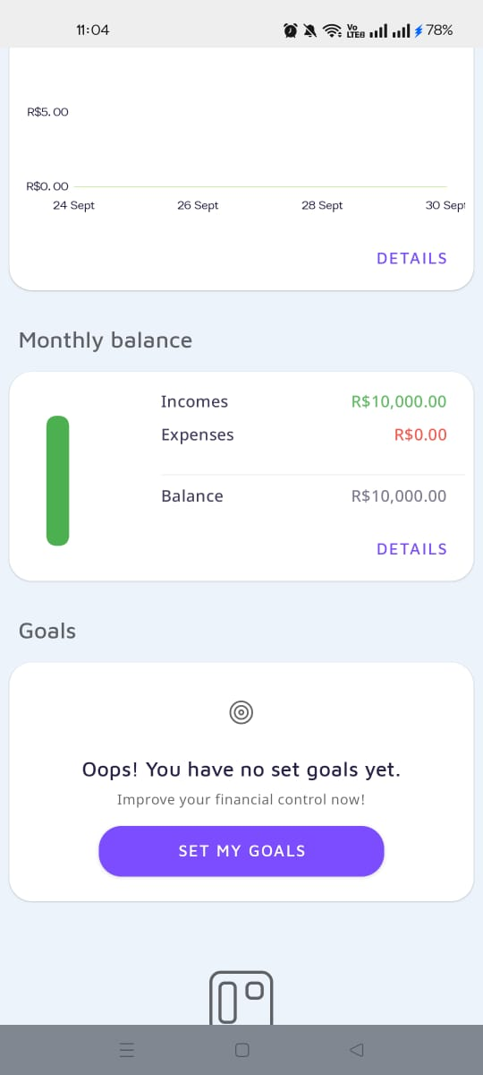
Figure 4:mobills dashboard(source :Mobills)
Figure 4 illustrates a snapshot of the Mobills app dashboard, showcasing its financial tracking features. The monthly balance section highlights a recorded income of R$10,000.00 with no expenses entered yet, resulting in a positive balance of R$10,000.00. This clear breakdown allows users to easily visualize their cash flow at a glance. Additionally, the goals section prompts the user to set personal financial goals, emphasizing the app’s focus on helping individuals plan and achieve better financial control. The clean and structured interface demonstrates Mobills’ user-friendly design, making it easy for users to monitor income, expenses, and savings objectives in one place.

2.4 Local Scale (Kenya)
In Kenya, the personal finance landscape is slowly evolving beyond notebooks, receipts, and memory-based tracking. Local developers have stepped in with innovative apps that are tailored to the realities of Kenyan users, who often juggle multiple income sources and irregular expenses. Unlike global platforms that assume seamless bank integrations, these apps CountPesa, Budget Yangu, and PesaTrail are designed for the everyday Kenyan who primarily manages money through mobile transactions, informal savings, and flexible budgets.

2.4.1 CountPesa
CountPesa is like having a trusted personal finance buddy right in your phone, especially if you use M-Pesa regularly. Imagine no longer having to painstakingly enter every little transaction manually CountPesa quietly and automatically captures every M-Pesa message, sorts your spending into easy-to-understand categories, and paints a clear picture of where your money goes. It's designed to give users a peaceful sense of control and clarity over their finances without the hassle.
People love CountPesa for making money management feel less like a chore and more like an empowering experience. It helps you spot those sneaky little expenses that add up and gently nudges you to stick to your budget before you overspend. And the best part? Your financial data stays locked safely on your phone, so no worries about privacy.
Imagine looking back over months and seeing your financial story unfold—how you’ve grown, where you’ve saved, and what habits to change. The app doesn’t boss you around; it shows you the facts with helpful visuals and insights, leaving the decisions in your hands. Many users find that having this overview encourages smarter spending without the stress.
In short, CountPesa turns managing money from a headache into a simple, friendly, and even enjoyable part of your daily life. It’s like having a financial coach who’s always there—clear, private, and easy to use. This is why many appreciate it as a game-changer for anyone wanting to master their personal finances with minimal effort
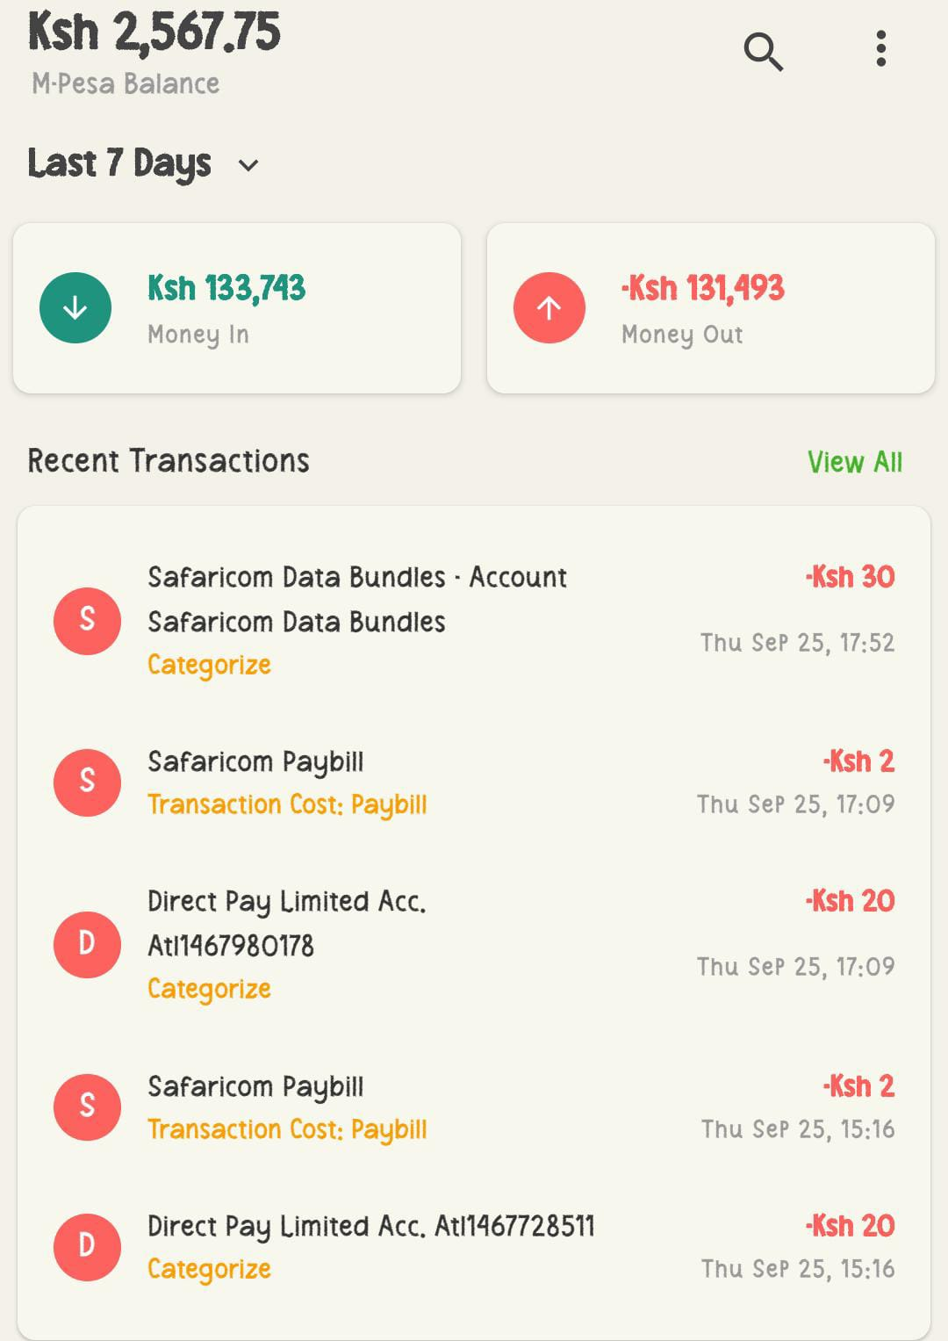
Figure 5: countpesa user interface (Source: CountPesa)
Figure 5 shows a personal finance app interface where the user’s M-Pesa balance (Ksh 2,567.75) is clearly displayed alongside a seven-day summary of money coming in (Ksh 133,743) and money going out (Ksh 131,493). The app also lists recent transactions such as airtime, pay bill payments, and merchant payments, with an option to categorize each expense. At the bottom, a trend graph visualizes daily spending, helping the user spot patterns at a glance.
In simple terms, the app does more than show balances it translates financial activity into meaningful insights by categorizing spending and visualizing trends. This makes it easier for users to track habits, avoid overspending, and plan better.

2.4.2 Pesatrail
PesaTrail is a mobile money management app designed to help users keep full control over their M-Pesa transactions and mobile loans. It acts as a personal financial assistant that tracks every shilling spent or borrowed across multiple mobile money and loan platforms, including Fuliza, M-Shwari, NCBA Now, KCB M-Pesa, Zenka, Tala, and Branch.
The app’s core features include tracking loan costs and facility fees from these various lending sources, recording detailed transaction histories, and offering insightful analyses of income versus expenses. Users can easily see where their money goes daily, monthly, and yearly, helping them make smarter financial choices. PesaTrail also supports searching and filtering transactions, making it simple to find specific payments or transfers, and allows exporting reports to PDF for record-keeping.
What truly sets PesaTrail apart is its security focus. It protects data with a PIN and encrypts information, giving users peace of mind that their financial data is safe. Upcoming features like budget management will further empower users to plan and control their spending.
Humanizing it, PesaTrail feels like having a vigilant financial companion who quietly watches over your money, loans, and spending habits always ready to give you a clear picture of your financial health. It’s especially helpful for anyone juggling multiple loans or wanting to avoid surprise fees that can eat into their budget. Instead of feeling overwhelmed by complex financial statements or multiple loan repayments, PesaTrail breaks everything down into simple, understandable insights you can act on. It helps users manage money with confidence, avoid debt traps, and build a more secure financial future all from their smartphone.
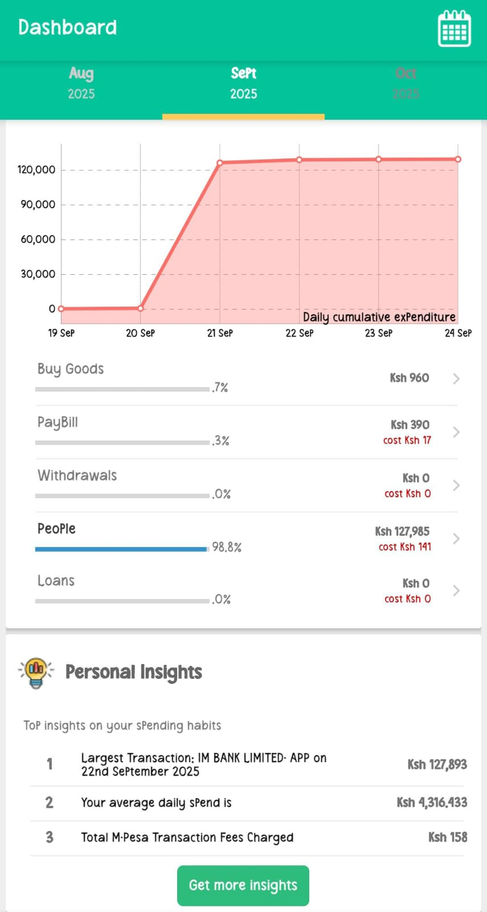Figure 6: Pesatrail dashboard(source :Pesatrail)
Figure 6 shows a personal finance app interface where the user’s M-Pesa balance (Ksh 2,567.75) is clearly displayed alongside a seven-day summary of money coming in (Ksh 133,743) and money going out (Ksh 131,493). The app also lists recent transactions such as airtime, paybill payments, and merchant payments, with an option to categorize each expense. At the bottom, a trend graph visualizes daily spending, helping the user spot patterns at a glance.
In simple terms, the app does more than show balances; it translates financial activity into meaningful insights by categorizing spending and visualizing trends. This makes it easier for users to track habits, avoid overspending, and plan better.

2.5 Strengths and Weaknesses of the Selected Systems

From the review of global, regional, and local financial management platforms, it is evident that each system brings valuable contributions to the way individuals interact with money, while also presenting clear limitations that leave gaps for improvement.

Table 1: Strengths and Weaknesses of the Selected Systems
system | strength | weakness
Mint (Global) | - Automatic expense tracking through bank integration.  - Bill reminders and credit score monitoring.  - Provides detailed financial insights. | - Heavily U.S./Canada focused.  - Overwhelming for beginners.  - Requires stable bank integrations not common in Africa.
YNAB (Global) | - Philosophy-driven budgeting (give every dollar a job).  - Encourages financial discipline and long-term planning.  - Active community and educational support. | - High subscription cost (~$14.99/month).  - Steep learning curve.  - Not localized for African financial realities
Spendee(regional) | - Supports multiple wallets (cash, bank, crypto).  - Clean and minimalistic dashboard.  - Allows syncing with bank accounts for real-time tracking.  - Flexible filtering options for categories and transactions. | -- Limited features in the free version; most advanced tools require premium.  - Budgeting features are not as detailed as competitors.  - Heavy reliance on internet connection for syncing.
Mobills(regional) | - Strong budgeting and financial planning tools.  - Allows users to set financial goals and track progress.  - Clear visualization of incomes, expenses, and balances.  - User-friendly interface tailored to (especially Brazil).Latin American markets | - Some advanced features locked behind premium subscription.  - Limited integration with banks compared to global apps like Mint.  - Can feel overwhelming for new users due to many options.
CountPesa(Local,kenya) |  | • Mainly tied to M-Pesa, less useful beyond mobile money.  • No advanced goal-setting or investments.  • Limited adoption and visibility.  • Still developing in terms of features.
  • Automates budgeting by capturing M-Pesa SMS transactions.
  • Provides clear visuals of hidden/frequent expenses.
  • Privacy-focused: keeps data on the user's phone.
  • Feels like a friendly financial buddy
Budget Yangu(Local, Kenya) | • Tailored to Kenyan realities (rent, school fees, groceries).  • Supports multiple income sources.  • Includes bill reminders and savings goals.  • Real-time visualizations make budgeting simple and motivating. | • Requires manual entry of expenses.  • No direct integration with mobile money or banks.  • Adoption is still low due to minimal marketing.  • Can feel repetitive for users over time.

Table 1 shows that while global, regional, and local systems have each made important contributions to personal finance management, none of them offers a complete solution that fits the realities of everyday Kenyan users. Global apps like Mint, YNAB, PocketGuard, and Fast Budget excel at automation, visual dashboards, and behaviour-driven budgeting. They turn financial chaos into clarity for millions worldwide. However, their reliance on advanced banking integrations, subscription costs, and lack of localization means that for most Kenyans who rely heavily on mobile money and informal savings these platforms feel distant, foreign, or simply out of reach.
Regional platforms such as M-Pesa Super App, Equity Eazzy App, and PiggyVest bring the conversation closer to home. They are accessible, relatable, and already embedded in people’s financial routines. M-Pesa has become the backbone of daily transactions, Eazzy App merges digital banking with convenience, and PiggyVest has made saving both popular and disciplined among young Africans. Yet, these platforms remain narrowly focused M-Pesa records transactions but does not budget, Eazzy is tied to one bank, and PiggyVest prioritizes savings without offering everyday spending analysis. They solve parts of the problem but not the whole.
Local innovations like CountPesa, Budget Yangu, and PesaTrail reveal that Kenyan developers understand the gaps global and regional apps have left. CountPesa automates M-Pesa transaction tracking and feels like a personal finance buddy; Budget Yangu provides relatable categories and goals that reflect Kenyan households; and PesaTrail offers comprehensive tracking of both expenses and mobile loans, with a strong focus on security. These apps bring budgeting closer to Kenyan realities. However, their weaknesses such as heavy reliance on manual input, limited awareness, and underdeveloped features mean that adoption has remained slow. They point in the right direction but fall short of becoming the go-to solution for the majority.
Overall, the strengths of these systems show what is possible, while their weaknesses highlight a clear gap for MoneyMate. There is a need for a web-based budgeting tool that is as automated as Mint, as disciplined as YNAB, as accessible as M-Pesa, and as culturally relevant as Budget Yangu but built specifically for Kenyans. MoneyMate has the potential to bridge these worlds, transforming fragmented financial practices into an empowering, holistic experience.

2.6 Conclusion
The review of global, regional, and local budgeting systems makes it clear that while progress has been made in personal finance management, there is still a major gap when it comes to solutions tailored for Kenyan realities. Global platforms like Mint and YNAB have demonstrated the power of automation, proactive budgeting, and visually engaging dashboards. They show us what is possible when technology meets discipline, but their foreign orientation, cost barriers, and lack of integration with African financial systems make them largely inaccessible to the average Kenyan.
On the other hand, regional systems such as the M-Pesa Super App, Equity’s Eazzy App, and PiggyVest prove that Africans are ready to embrace digital tools that simplify financial transactions, encourage savings, and improve convenience. Yet, they only address isolated aspects of money management. They provide a foundation, but they stop short of offering a full budgeting ecosystem that can guide individuals and households from day-to-day spending control to long-term financial planning.
The most promising direction lies in local innovations like CountPesa, Budget Yangu, and PesaTrail. These systems speak directly to Kenyan lifestyles, tracking cash and mobile money transactions, providing relatable categories, and securing financial data. However, their weaknesses in manual processes, low adoption, and underdeveloped features — reveal that the journey toward a truly effective budgeting tool is far from over.
In essence, Chapter Two highlights both inspiration and opportunity. The global platforms inspire us with their sophistication, the regional ones remind us of the power of accessibility, and the local systems show us the importance of cultural and contextual relevance. Together, they point to a clear need: a comprehensive, human-centered budgeting web application designed for Kenyan users. This sets the stage for Chapter Three, where the analysis will focus on defining the specific problem Money Mate seeks to solve, its objectives, and the requirements for building a solution that is both practical and empowering.

CHAPTER THREE: AIMS AND OBJECTIVE

3.1 General Aims and Objectives
The overall objective of this project is to develop an efficient and user-friendly personal finance management system, named Money Mate, designed to help users track their income, expenses, budgets, and savings goals with ease. The system aims to replace traditional, manual budgeting methods such as handwritten records or spreadsheets with an interactive and automated web-based platform. By digitizing financial tracking, Money Mate will make it easier for individuals to monitor their spending habits, plan savings, and make informed financial decisions. Ultimately, the project seeks to promote better money management, improve financial discipline, and empower users to achieve their financial goals.
A comprehensive review of existing budgeting and financial tracking applications such as Mint, Spendee, and Mobills was conducted to guide the project’s development. The analysis revealed several limitations among current tools, including limited customization for local contexts, complex interfaces, and high subscription costs. Additionally, some apps lack real-time synchronization or fail to provide users with meaningful insights based on their spending patterns. These gaps highlighted the need for an accessible, affordable, and intuitive solution like Money Mate that combines simplicity, effectiveness, and personalization to meet diverse user needs.
Building on these insights, the design of Money Mate focuses on simplicity, scalability, and real-time functionality. The system will feature a clean, modern interface that allows users to log income and expenses, set budgets, and track savings goals effortlessly. It will also generate visual reports and alerts to help users understand their financial behavior and avoid overspending. The architecture will integrate cloud-based data storage for secure access across multiple devices, ensuring convenience and reliability. Robust security measures, such as encrypted authentication and data protection, will safeguard sensitive financial information.
To ensure the system meets user expectations, a series of testing and evaluation phases will be conducted. Functional testing will verify that all features such as transaction logging, goal tracking, and report generation work as intended. Usability testing will engage real users to evaluate the app’s simplicity, design, and ease of navigation. Performance testing will assess the system’s responsiveness and reliability under various conditions. Additionally, a pilot test with a small group of users will provide valuable feedback to refine features before full deployment. The final outcome will be a reliable, accessible, and impactful financial management tool that helps individuals take control of their finances and plan for a more secure future.

3.2 Specific Aims and Objectives
The specific aims and objectives of the Money Mate project are to:
- Analyze existing personal finance management applications to identify their strengths, weaknesses, and areas for improvement, focusing on usability, affordability, and functionality.
- Design and develop a modular financial management system that allows users to record income and expenses, set budgets, and track savings goals in real-time. The system will include features such as visual financial summaries, automated spending alerts, and data synchronization across devices for a seamless user experience.
- Implement a secure and scalable backend architecture to ensure reliable system performance, including safe storage of user data, encrypted login processes, and smooth integration with APIs for data analysis and reporting.

3.3 Conclusion
This chapter has laid the foundation for the development of Money Mate by clearly defining the problem and outlining the objectives of the system. It highlighted the financial management struggles faced by many Kenyans, such as poor expense tracking, lack of savings discipline, and the limitations of existing solutions, both global and local. The problem statement made it clear that there is a pressing need for a comprehensive, user-friendly, and contextually relevant budgeting tool.
The objectives established in this chapter provide a roadmap for addressing this gap. By combining simplicity, automation, goal-setting, and security, Money Mate is envisioned as more than just a digital ledger; it will serve as a financial companion that helps users build better money habits and gain confidence in their financial decisions. With these goals in place, the next chapter will focus on the design and methodology of the system, translating the vision into a practical, workable solution.

CHAPTER FOUR: PROPOSED PROJECT
The proposed project focuses on developing a centralized and efficient personal finance and expense tracking system that simplifies the process of budgeting, monitoring income and expenses, and building savings habits. The system, named Money Mate, is designed to reduce the burden of manual record-keeping, improve financial awareness, and increase users’ ability to make informed decisions by introducing a digitized, structured, and real-time budgeting platform. It specifically targets students, professionals, and households who often struggle with tracking their money consistently using traditional, informal methods such as notebooks, spreadsheets, or mere memory.
Money Mate will operate as a web-based application that allows users to record income and expenses, categorize transactions, and generate personalized reports. The system will feature secure user authentication, a visually engaging dashboard, and real-time charts to help users see where their money is going. In addition, users will be able to set budget limits, receive timely alerts when they are close to overspending, and track progress toward financial goals such as savings for emergencies, education, or investments. By focusing on automation where possible, the platform aims to minimize the frustration of manual data entry while maximizing accuracy and convenience.
The application will also include a dedicated dashboard where users can view summaries of their financial activity through interactive visualizations. This dashboard will provide insights such as income versus expenses, category breakdowns, and month-to-month comparisons, empowering users to recognize spending patterns and adjust their habits. To encourage accountability, MoneyMate will generate downloadable reports and offer customizable features like reminders for recurring expenses. Administrators of the platform will have access to an advanced back-end management system to monitor performance, resolve technical issues, and support scalability.
Designed to be scalable and user-friendly, the system will allow for future integration with financial institutions, mobile money APIs, and even AI-powered features such as predictive budgeting and personalized financial recommendations. By leveraging modern software development practices, MoneyMate seeks to enhance financial literacy, transparency, and discipline, making it more than just a tracking tool. Instead, it will serve as a digital financial companion that promotes smarter spending, consistent saving, and long-term financial stability.
In summary, this proposed project bridges the gap left by existing budgeting solutions by delivering a platform that is accessible, contextualized to Kenyan realities, and empowering to users. With real-time updates, intuitive design, and features tailored to local financial practices, Money Mate has the potential to transform the way individuals and households manage their money, one transaction at a time.

4.1 Project Phases
The development of Money Mate will be executed in three main phases: Research and Requirements Gathering, System Design and Implementation, and Testing, Documentation, and Presentation. These phases are carefully structured to ensure that the system achieves its intended objectives of improving financial discipline, enhancing usability, and remaining accessible to a wide range of users.

4.1.1 Phase One: Research, Requirements Gathering, and System Design
This initial phase will lay the foundation for the development of Money Mate. It will involve extensive research on existing personal finance and budgeting platforms, both locally and internationally, to identify their strengths, limitations, and opportunities for improvement. Input from potential users including students, young professionals, and households will be gathered through surveys, interviews, and informal discussions to understand their financial management challenges and expectations.
The insights collected will guide the definition of key features such as secure login, expense and income tracking, budget-setting tools, goal management, real-time alerts, and user dashboards. The phase will also involve drafting wireframes and mock-ups of the interface to visualize user workflows and ensure the system is intuitive, visually engaging, and simple to navigate. Suitable technologies and tools will be selected to support the creation of a scalable, secure, and responsive web-based platform.

i. Research
The research phase will begin with a comprehensive review of existing personal finance applications and budgeting platforms. This review will focus on identifying global trends, assessing the strengths and weaknesses of current solutions, and highlighting functionality gaps that MoneyMate can address. Both global (e.g., Mint, YNAB, PocketGuard) and local platforms (e.g., CountPesa, Budget Yangu, PesaTrail) will be studied to gain a broad understanding of common practices, cultural contexts, and user preferences.
Potential technologies will also be evaluated to ensure that the system is modern, scalable, and responsive. These may include cloud hosting options such as Firebase or AWS, database solutions like Firestore or MongoDB, and frontend frameworks such as React.js or Vue.js. Tools for data visualization (e.g., Chart.js, D3.js) will be explored to create engaging dashboards, while security measures like encryption and secure authentication protocols will be considered to protect sensitive financial data.
The main deliverables for this phase will include a Technical and Functional Requirements Document outlining the essential features, and an Evaluation Report on Tools and Technologies assessing the suitability of different solutions based on cost, scalability, and performance. This phase is expected to take one week.
ii. Requirements Gathering
During this phase, the project team will engage with potential users to collect detailed insights into their money management needs. This will involve understanding pain points such as difficulty in tracking expenses, lack of budgeting discipline, and absence of savings reminders.
From this, user stories and interaction workflows will be developed to shape MoneyMate’s functionality, showing how different types of users such as students managing allowances, employees balancing salaries, or households planning monthly expenses will interact with the platform. Security requirements such as strong password authentication, role-based access (for admin and standard users), and privacy protocols will also be specified.
Key deliverables will include a User Requirement Specifications (URS) Document that covers both functional and non-functional requirements, along with Workflow Diagrams and Feature Definitions mapping out system interactions. This phase is planned to take one week.

iii. Proposal
In this phase, a detailed project proposal will be drafted to define the scope of MoneyMate. The proposal will include the system architecture, key features, implementation timeline, resource allocation, and potential risks. It will also provide a development roadmap, identifying possible challenges such as user adoption barriers or technical constraints.
Once completed, the proposal will be presented to stakeholders (e.g., project supervisors, evaluators, and potential users) for review and approval to ensure alignment with project objectives and user needs before moving into implementation.
The main deliverable will be an Approved Project Proposal Document, which will serve as the official guide for subsequent phases. This stage is expected to take two weeks.

iv. System Design
In the system design phase, the core components of MoneyMate will be defined and structured to ensure seamless integration. This process will begin with wireframes and mockups of the interface, providing visual representations of how users will navigate features like adding expenses, setting goals, or viewing reports. The designs will prioritize simplicity and engagement to ensure that the app feels friendly and easy to use.
A database schema will be developed to store user data such as income, expenses, savings goals, and reports. The schema will be optimized for scalability, privacy, and performance. The system architecture will define how the frontend (user interface) and backend (server, database) interact, focusing on real-time updates, secure handling of financial records, and smooth communication between components. APIs will be defined to enable future integration with third-party systems, such as mobile money or banking services.
The deliverables for this stage will include System Architecture Diagrams, Database Schemas, and High-Fidelity Interface Designs.

4.1.2 Phase Two: System Coding
This phase focuses on developing the system architecture, designing the user interface, and implementing the core functionalities of Money Mate. Building on the requirements and design specifications from Phase One, the development team will translate plans into a working platform capable of real-time expense tracking, secure data storage, and efficient user interactions. The system will be designed to be flexible and scalable to meet the needs of users, while ensuring a user-friendly experience and maintaining high performance.
i. System Architecture Design
The initial stage of implementation will involve designing a robust and scalable architecture for Money Mate. This will include defining the system’s core components, mapping their interactions, and selecting suitable technologies to support the platform. The architecture will ensure that Money Mate can handle real-time budget updates, generate accurate reports, and securely manage user financial records. Key components will include the frontend interface, backend logic, and a secure database layer, all connected through APIs for seamless communication.

ii. System Frontend
The frontend of Money Mate will serve as the main interface where users interact with the system, and it will be built using React.js alongside HTML5, CSS3, and JavaScript for structure and styling. The design will focus on simplicity and clarity, ensuring that budgeting feels approachable for everyone, whether a student just starting out or a professional managing multiple expense. Key features will include secure login and signup pages, an interactive dashboard that displays income, expenses, savings goals, and balances, as well as intuitive forms for recording transactions with easy-to-use category selectors. To make financial insights more engaging, the frontend will incorporate data visualizations such as pie charts and line graphs, while notifications and alerts will guide users by warning them of overspending or reminding them of upcoming bills. Modern UI practices will be applied throughout to guarantee smooth navigation, fast load times, and real-time updates. React’s state management will ensure that data remains in sync, while consistent styling—possibly supported by a UI library like Ant Design will give the app a polished, professional feel. Most importantly, accessibility standards will be followed so that the platform is inclusive and user-friendly for all.

iii. System Backend
The backend of MoneyMate will be built using Node.js, selected for its scalability and efficiency in managing multiple user requests at once. Acting as the engine of the system, the backend will handle all core business logic, validate incoming data, and serve as the bridge between the frontend and the database. Its responsibilities will include secure user authentication and authorization to protect accounts, as well as transaction management for adding, updating, deleting, and retrieving income or expense records. It will also support budget and goal tracking by calculating balances, monitoring progress, and issuing overspending warnings, while report generation tools will produce clear summaries of financial activity for users. To ensure the highest level of trust, the backend will implement strong security protocols such as encryption and strict data validation to safeguard sensitive information. For hosting, platforms like Azure or Firebase Cloud Functions will be used to guarantee reliable performance, real-time responsiveness, and the ability to scale as the number of users grows.

iv. Database
MoneyMate will rely on Firebase Firestore or MongoDB as its primary database, both of which are known for their flexibility, scalability, and secure management of sensitive financial data. The database schema will be carefully structured to store essential information such as user profiles with hashed passwords, detailed records of income and expenses categorized by amount, date, and source, as well as user-defined savings goals and budget limits. In addition, system logs will be maintained to track user activities and ensure accountability within the platform. Security will be a top priority, with measures like role-based access rules, encryption, and Firebase Authentication tokens safeguarding every interaction. To enhance the user experience, real-time listeners will be implemented so that any updates such as adding a new expense are instantly reflected on the user’s dashboard without delays, keeping the system both responsive and reliable.

v. System Integration
System integration will ensure smooth communication between all components of MoneyMate. APIs built with Node.js will serve as middleware, connecting the React frontend to the Firestore/MongoDB backend. This integration will enable real-time data flow, secure user authentication, and synchronization of financial records.
Version control will be managed with GitHub, allowing the team to collaborate, push code updates, and resolve issues through commits and pull requests. Continuous deployment pipelines may be set up using GitHub Actions and cloud hosting services, ensuring efficient deployment and minimal downtime.

vi. Core Functionality Implementation
With the architecture, frontend, backend, and database in place, the next step will be to bring MoneyMate to life by implementing the core functionalities that make it fully operational. At the heart of these features will be secure user account creation and login, along with tools for tracking income and expenses that are neatly categorized for clarity. Users will also be able to set budgets and receive timely alerts when they are at risk of overspending, as well as create savings goals and monitor their progress over time. A personalized dashboard will summarize balances, income, and expenses while displaying visual charts to make financial insights more engaging. To further support users, the system will include notifications and reminders for bills or spending limits, plus additional features such as exporting reports to PDF or Excel, advanced search and filtering tools, and feedback options for continuous improvement. Strong security measures including input validation, password encryption, and HTTPS protocols will be enforced to keep financial data safe. The outcome of this phase will be a fully functional prototype of Money Mate with all essential features, ready for thorough testing.

4.1.3 Phase Three: Testing, Documentation, and Presentation
This phase focused on validating the Money Mate system to ensure it met all functional and performance expectations. It also involved documenting every stage of development and preparing a final presentation to effectively communicate the project’s purpose, design, and impact.

i. Software Testing and Evaluation
In this phase, Money Mate will undergo a series of structured tests to verify its functionality, performance, and usability. The objective is to ensure the system meets all predefined requirements and provides a seamless experience for end users.
Unit Testing will be performed first to verify the correctness of individual components, such as the login module, transaction entry forms, budgeting alerts, and dashboard visualization features. Each module will be tested independently to identify and resolve any isolated issues before integration.
Integration Testing will follow, focusing on the interaction between system components. This will ensure that data flows correctly from the frontend (React.js) to the backend (Node.js) and into the Firestore or MongoDB database. The integration of real-time updates, data visualizations, and goal tracking mechanisms will be closely monitored and validated.
User Acceptance Testing (UAT) will be carried out with selected end users such as students, professionals, and household representatives. Their interactions with the system will provide valuable feedback on usability, clarity of features, and overall system experience. Adjustments will be made based on their input to improve navigation, financial reporting, and goal-setting accuracy.
Throughout this phase, any identified bugs or performance issues will be addressed promptly. Optimization efforts will also be implemented to ensure responsive design across different devices and fast load times. This testing process will guarantee that MoneyMate is stable, secure, and ready for deployment, ultimately delivering a reliable solution for personal budgeting and expense management.

ii. Project Write-Up
The Documentation phase will focus on creating detailed and comprehensive records of the entire project lifecycle. This will include documenting the research, design, development, and testing processes to provide a clear understanding of how MoneyMate evolved.
A thorough final project report will summarize the methodology, challenges encountered, solutions implemented, and overall outcomes of the project. In addition, a User Manual will be developed to guide users in effectively navigating the system. This manual will include step-by-step instructions for account creation, adding income and expenses, setting budgets and savings goals, and interpreting dashboard reports.

iii. Final Presentation and Submission of Report
During the Final Presentation and Submission phase, a comprehensive presentation will be prepared to demonstrate the completed MoneyMate system and its core functionalities. The presentation will highlight key features such as income and expense tracking, goal-setting, visual dashboards, and notifications, while also showcasing improvements made based on user feedback throughout the development process.
The final project report, along with the complete source code and related documentation, will be submitted as evidence of project completion. This presentation will not only show the technical aspects of MoneyMate but also emphasize its impact giving users better control over their finances and helping them build sustainable financial habits.
4.2 Program of Work
The Program of Work outlines the structured execution of each phase of the MoneyMate project, ensuring that all objectives are achieved systematically and within the planned timeframe. It provides a roadmap for managing the project lifecycle, guiding the process from research and requirements gathering to the final deployment and presentation.
By breaking down the work into distinct and manageable stages, the program ensures that development is well-coordinated, potential challenges are identified early, and resources are effectively utilized. Each stage builds upon the progress of the previous one, creating a clear and logical progression toward delivering a reliable, user-friendly, and scalable personal finance system.
The work plan will therefore cover the following:
- Phase One: Research, Requirements Gathering, and System Design – to define user needs, identify system features, and create wireframes and technical specifications.
- Phase Two: System Coding – to implement the core architecture, user interface, backend logic, and database integration.
- Phase Three: Testing, Documentation, and Presentation – to validate system performance, compile reports and manuals, and present the completed solution.
This systematic approach not only ensures smooth execution but also creates room for iteration and improvement at every stage, allowing MoneyMate to evolve into a solution that meets both technical and user expectations.

4.2.1 Phase One: Research, Requirements Gathering, and System Design
The first phase of the Money Mate project focuses on identifying user needs, analysing existing financial management challenges, and laying the foundation for effective system development. Research will be conducted to understand how individuals currently manage their personal finances, revealing gaps in budgeting discipline, tracking expenses, and setting savings goals. Key stakeholders such as students, professionals, and households will provide input through interviews, surveys, and informal discussions to define essential system features such as income and expense tracking, budget setting, goal management, and personalized dashboards.
i. Research
Objective
To analyse existing budgeting and personal finance systems, identify best practices, and determine the most suitable technologies for developing Money Mate.
Tasks
- Conduct market research on global and local personal finance applications (e.g., Mint, YNAB, CountPesa, Budget Yangu).
- Identify optimal programming languages, frameworks, and tools (e.g., React.js, Node.js, Firebase, MongoDB).
- Engage with potential users (students, workers, households) to gather detailed requirements and expectations.
- Analyse key issues such as overspending, lack of savings discipline, and poor financial visibility.
- Research technical and functional requirements for scalability, security, and usability.
Deliverables
- Technical and Functional Requirements Document outlining system features, tools, and frameworks.
Timeline
- 5 days

ii. Requirements Gathering
Objective
To gather detailed technical and functional requirements to ensure MoneyMate meets stakeholders’ needs.
Tasks
- Conduct user surveys and interviews to understand budgeting challenges.
- Define system requirements (income/expense tracking, alerts, savings goals, reports).
- Specify both functional and non-functional requirements (security, performance, scalability).
- Review existing financial tracking solutions for inspiration and gaps.
Deliverables
- User Requirements Specifications (URS) Document.
Timeline
- 5 days

iii. Proposal Development
Objective
To create a structured project proposal that outlines the development strategy, scope, and key features of MoneyMate.
Tasks
- Draft a comprehensive project proposal detailing goals, methodology, and implementation approach.
- Define core features such as transaction tracking, goal management, reports, and budget alerts.
- Establish milestones and a clear project timeline to guide execution.
- Present the proposal for feedback and incorporate improvements.
Deliverables
- Project Proposal Document describing objectives, development strategy, and expected outcomes.
Timeline
- 1 week

iv. System Design
Objective
To develop a complete system blueprint for Money Mate, including user interface designs, database schema, and system architecture.

iv. System Design
Objective
To develop a complete system blueprint for Money Mate, including user interface designs, database schema, and system architecture.
Tasks
User Interface & Experience Design
- Create wireframes and mock-ups for signup, login, dashboard, transactions, and reporting pages.
- Ensure responsive and user-friendly designs for both desktop and mobile platforms.
- Design navigation flows for recording income/expenses, setting budgets, and viewing reports.
Database Schema & Architecture Development
- Design a Firestore/MongoDB schema to handle users, income, expenses, goals, and reports.
- Structure collections and relationships to support scalability and real-time data updates.
- Define interactions between frontend, backend, and database layers.
System Architecture Definition
- Design backend logic for managing transactions, budgets, alerts, and reports.
- Establish API routes for seamless communication between system components.
- Plan for performance optimization, real-time synchronization, and secure data storage.
Deliverables
- Wireframes & Mock-ups (UI designs for all user flows).
- Database Schema (collections and relationships).
- System Architecture Document (data flow diagrams, API structure).
Timeline
- 1 week

4.2.2 Phase Two: System Implementation
The implementation phase focuses on building the MoneyMate application with emphasis on reliability, responsiveness, and scalability. This stage involves setting up development tools, developing key system components, integrating internal and external APIs, and preparing the application for deployment on a cloud platform. The implementation process is divided into four core activities: Frontend Development, Backend Development, API Integration, and Deployment.

i. Frontend Development
Objective
To develop a user-friendly and responsive interface that allows users to track expenses, set budgets, and monitor financial goals efficiently.
Tasks
- Set up the frontend environment using React.js for dynamic and modular interface development.
- Design and implement UI components such as sign-up/login forms, dashboards, transaction logs, and budget progress trackers.
- Ensure the interface is responsive and accessible across desktop, tablet, and mobile devices.
- Enable real-time updates to reflect changes in income, expenses, and goal progress.
Deliverables
- Fully functional and interactive user interface with all core features implemented.
- Mobile-first responsive design ensures compatibility across devices.
Timeline
- 1 week
ii. Backend Development
Objective
To build a secure and scalable backend system for managing user accounts, financial transactions, budget goals, and notifications.
Tasks
- Set up the backend environment using Node.js/Express for server-side logic.
- Implement authentication and role-based access (regular users vs. admin for system monitoring).
- Develop backend logic for transaction recording, budget tracking, savings goal management, and report generation.
- Integrate notification services (e.g., email alerts or push notifications) for reminders and budget limits.
- Apply data validation and security measures (encryption, hashed passwords, secure communication).
Deliverables
- Complete backend server with all business logic and authentication mechanisms.
control integrated with Firebase Authentication (or JWT).
Timeline
- 1 week
iii. API Integration
Objective
To enable seamless communication between frontend and backend systems and incorporate necessary third-party services.
Tasks
- Define and implement internal RESTful APIs for managing transactions, budgets, and reports.
- Integrate Firestore/MongoDB API for real-time data storage and retrieval.
- Configure APIs to support budget alerts, savings progress tracking, and financial summaries.
- Test and document all API endpoints for accuracy, consistency, and performance.
Deliverables
- Fully integrated APIs for user interaction, data management, and notifications.
- API documentation outlining endpoints, request formats, and expected responses.
Timeline
- 3 days
iv. Deployment
Objective
To host MoneyMate on a secure, scalable, and accessible cloud platform to ensure 24/7 availability and high performance.
Tasks
- Choose and configure a cloud hosting platform (e.g., Firebase Hosting, Vercel, or AWS).
- Deploy frontend and backend components to the selected environment.
- Set up Continuous Deployment (CD) workflows for seamless updates.
- Perform live environment testing to verify system performance, security, and usability.
- Monitor and log system usage and errors for ongoing optimization.
Deliverables
- Fully deployed web application accessible via a secure domain.
- Cloud infrastructure configured for scalability, monitoring, and version control.
Timeline
- 3 days

4.3 Gantt Chart
A Gantt chart is a visual project management tool used to plan, schedule, and monitor the progress of tasks within a project. For the MoneyMate system, the Gantt chart acts as a detailed roadmap that outlines the entire development lifecycle from initial research and requirements gathering, through coding and integration, to testing, documentation, and final presentation. It breaks the project into clear phases with defined timelines, highlights task dependencies, and marks key milestones. This structured timeline ensures that development stays on track, resources are managed effectively, and all deliverables are completed within the scheduled timeframe.
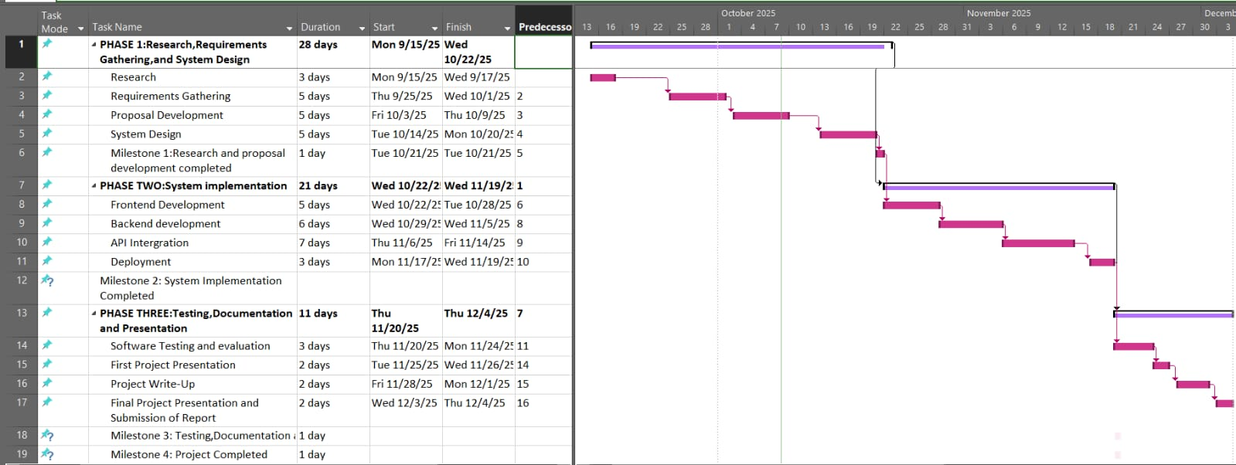

Figure 7: gantt chart
Figure 7 illustrates the Gantt chart for the MoneyMate project, showing how the different phases and tasks are planned and spread out from September to December 2025. The chart clearly breaks the project into three main phases: research and requirements gathering, system implementation, and finally testing, documentation, and presentation. Each task under these phases is represented by horizontal bars that map out their duration and deadlines across the timeline at the top.
For example, the first phase research and requirements gathering runs from early September to mid-October, covering activities such as research, proposal development, and system design. Once this is completed, the implementation phase begins in late October, focusing on frontend development, backend development, API integration, and deployment. Finally, the last phase starts in mid-November, where the system undergoes testing, write-up, and final presentations until early December. The visual layout helps demonstrate dependencies between tasks, shows where milestones fall, and provides a clear roadmap to track progress, ensuring that the project remains on schedule and all deliverables are met.

4.4 Requirements
Phase One: Research and Requirements Gathering (September 8 – October 20, 2025)

This first phase set the foundation for the MoneyMate project by combining research, requirements gathering, proposal development, and system design into a structured process. The phase officially began on September 8 with in-depth research lasting until September 12, aimed at analysing existing budgeting applications and identifying best practices as well as functionality gaps. Following this, requirements gathering took place from October 1 to October 2, where potential users such as students, workers, and households were consulted to better understand their budgeting habits and challenges. Between September 16 and September 19, the project team focused on proposal development, defining Money Mate’s objectives, features, and scope. Finally, system design was conducted from September 22 to September 25, producing wireframes, workflows, and database schemas that would guide later stages of development. This phase concluded with Milestone 1: Research and Proposal Development Completed on October 18, 2025, marking the successful setup of a strong foundation for the system.

Phase Two: System Implementation (October 21 – October 31, 2025)

The second phase moved the project from planning into action by focusing on the actual development of MoneyMate. It began on October 21 with frontend development, which ran until October 23. During this stage, the user interface was built to be clean, responsive, and user-friendly, ensuring that users could easily report income, record expenses, and track their balances. Immediately after, backend development took place from October 24 to October 28, where the server-side logic was coded to securely manage transactions, budgets, and user accounts. On October 29 and 30, the team concentrated on API integration, connecting the frontend and backend to enable smooth data flow and real-time updates. Finally, deployment was carried out on October 31, ensuring the system was live on a cloud platform and ready for testing. This phase wrapped up with Milestone 2: System Implementation Completed, marking a critical step where MoneyMate transitioned from design into a functioning prototype.

Phase Three: Testing, Documentation, and Presentation (November 17 – December 1, 2025)
The final phase focused on refining and validating MoneyMate before delivery. Starting November 17, the team carried out software testing and evaluation for six days to ensure that all features worked smoothly and securely. This testing included functionality checks, integration tests, and user acceptance testing with feedback from potential users. Once the system was stable, attention turned to project documentation between November 27 and November 28. A full project report was prepared, outlining the research, design, development process, and key lessons learned, alongside a user guide for easier adoption. On November 24 and 26, the first project presentations were held, allowing stakeholders to see the system in action and provide feedback. Finally, the project concluded with the final presentation and official submission of the report on December 1, 2025. This phase ended with Milestone 3: Testing, Documentation, and Presentation Completed, confirming that MoneyMate was not only functional but also well-documented and ready for use.

Dependencies
The project was carefully structured so that every task built on the one before it, creating a smooth and logical workflow. For example, system design only began after the proposal had been completed, ensuring that the technical blueprint was based on clear objectives. Similarly, backend development only started once the frontend foundation was in place, while API integration required both the frontend and backend to be functional before connecting them. Testing and documentation were dependent on successful deployment, which guaranteed that the system being tested was live and stable. This chain of dependencies minimized the risk of delays, avoided confusion, and kept the team focused on one clear step at a time.

Milestones
The project was guided by three key milestones that acted as checkpoints to measure progress. The first milestone, achieved on October 18, 2025, marked the successful completion of research, requirements gathering, proposal development, and system design laying a strong foundation for the rest of the project. The second milestone, reached on October 31, 2025, represented the end of the system implementation phase, where MoneyMate was fully developed, integrated, and deployed into a working environment. The final milestone, on December 1, 2025, confirmed the completion of testing, documentation, and presentation, officially signalling that MoneyMate was polished, reliable, and ready for delivery. These milestones not only provided structure but also gave the project team clear goals and motivation at every stage
4.4 Requirements
Below are the technical, hardware, and budget requirements for the development and deployment of the MoneyMate budgeting system

4.4.1 Software Requirements
- Frontend Development: React.js (for building an engaging and interactive user interface that supports dashboards, charts, and responsive design).
- Backend Development: Node.js (for handling server-side logic, user authentication, and RESTful APIs).
- Database: Firebase Firestore (for real-time data storage, synchronization, and secure user data handling).
- Hosting: Firebase Hosting or Microsoft Azure (depending on scalability and deployment preferences).
- Development Environment: Visual Studio Code (VS Code) will be the primary code editor for development.
- Version Control: Git/GitHub (for source code management, version tracking, and collaborative work).

4.4.2 Hardware Requirements
- Workstations: Modern PCs or laptops with updated specifications (at least 8GB RAM, Intel i5 or higher processor) to support development, testing, and deployment.
- Server Infrastructure: Cloud infrastructure (Firebase or Azure) to manage backend services, authentication, and database hosting.
- Mobile Devices: Smartphones or tablets will be used to test the responsiveness and usability of the MoneyMate web app across different platforms.

4.4.3 Server Requirements
- Database and Authentication Server: A secure, cloud-hosted server (Firebase Authentication + Firestore) to handle login, authorization, and structured financial data storage.
- Notification Services: Firebase Cloud Messaging (FCM) or equivalent to support real-time alerts and reminders.

Budget Requirements
- Development Costs: No significant costs are anticipated since MoneyMate will rely on open-source tools and free-tier services (Firebase, GitHub, VS Code). However, minimal hosting or scaling expenses may arise if the project expands beyond the free-tier usage limits.
4.5 Conclusion
This chapter has outlined the key requirements for the development of MoneyMate. By leveraging technologies such as React.js, Node.js, and Firebase, the system is designed to provide a secure, scalable, and user-friendly platform for managing personal finances. Tools like Visual Studio Code streamline the development process, while cloud platforms such as Firebase and Azure ensure reliable hosting and smooth deployment.
The selected technologies not only minimize costs but also maximize efficiency, making Money Mate both practical and sustainable. With the software, hardware, and budgetary requirements clearly established, the next chapter will explore the system architecture and design. This will include architectural diagrams, data models, user interaction workflows, and detailed descriptions of system components providing a clear blueprint for how MoneyMate will function and deliver its intended value.

CHAPTER FIVE: SYSTEM ARCHITECTURE AND DESIGN

5.1 Introduction
This chapter presents the system architecture and design of MoneyMate, the personal finance and expense tracking web application. It outlines how the system components interact, how data flows between the frontend, backend, and database, and how the overall structure ensures efficiency, security, and scalability.
The design follows a user-centered approach, meaning that every feature and workflow is created with the user’s experience in mind. The architecture is based on a three-tier structure (frontend, backend, and database), ensuring modularity, easy maintenance, and flexibility for future scaling. By combining modern technologies like React.js, Node.js, and Firebase, the system is designed to provide real-time tracking, fast updates, and a smooth user experience.

5.2 System Models
System models are vital tools in the design and development of modern web applications, as they provide both a visual and logical framework for understanding how a system operates internally and interacts with its users. For MoneyMate, these models illustrate how different types of users (such as individuals managing their personal finances and administrators overseeing the system) interact with the platform’s modules and database.
The models help clarify the structure, workflow, and operations of MoneyMate, ensuring that both the development team and stakeholders have a shared understanding of how the system will function. They also make it easier to identify potential bottlenecks, design user-friendly workflows, and plan for scalability.
The diagrams and models presented in the following sections include architectural models, use case scenarios, process workflows, and system interaction diagrams. These provide a comprehensive blueprint of how users will record transactions, view analytics, set budgets, and receive feedback through the system. Collectively, they form a solid foundation for the development, testing, and eventual deployment of MoneyMate, while also serving as a reference point during evaluation and future upgrades.

5.2.1 System Architecture Overview
A system architecture is the high-level design that explains how the different parts of a software system are structured and how they interact with each other. It outlines the major components such as the frontend where users interact, the backend that processes business logic, and the database where information is stored and shows how data flows between them. In simple terms, it serves as a blueprint or map of the system, helping developers, stakeholders, and users understand how the application works internally and externally. For a project like the system architecture would illustrate how the user interface connects with the backend services, how data is stored and retrieved from the database, and how all these elements come together to provide a seamless budgeting and expense-tracking experience.

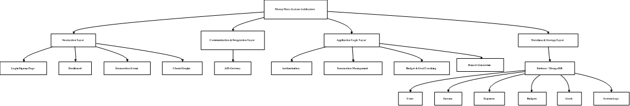
Figure 8: system architecture diagram
Figure 8 illustrates the system architecture of Money Mate, showing how the different layers of the application work together to deliver a smooth budgeting and personal finance experience. At the top, the interaction layer represents the frontend, where users access the system through a web-based interface built with HTML, CSS, and JavaScript. This is where they log in, record expenses, set budgets, and view financial summaries.
Beneath this, the communication and integration layer ensure that requests from the user interface are securely transmitted to the backend. This layer is responsible for API calls, data exchange, and handling communication between the client side and server side.
The application logic layer (backend), developed in PHP, processes these requests by applying business rules, validating data, managing transactions, and generating reports. It ensures that income and expense records are properly handled, budgets are tracked, and security measures like authentication and authorization are enforced.
At the base, the database and storage layer (using Firebase Firestore or MongoDB) stores all financial data, including user profiles, income, expenses, savings goals, and activity logs. This layer also supports real-time updates so that any changes made like recording a new expense are immediately reflected in the user’s dashboard.
Together, these layers create a structured and reliable architecture that balances usability, performance, and security, ensuring Money Mate runs efficiently for its user

5.2.2 Use Case Diagram
A use case diagram is like a simple map that shows how people interact with a system. Instead of diving into the technical details, it focuses on what the system should do. It highlights the different types of users (known as actors) and the main tasks they can perform, giving a clear picture of the system’s core functions in an easy-to-understand way.
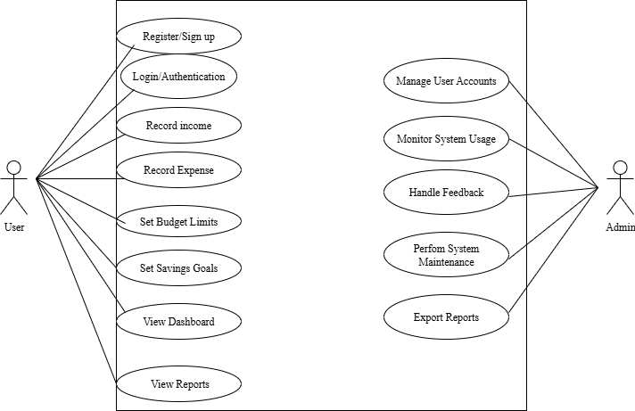Figure 9: Use Case diagram
Figure 9 illustrates the Use Case Diagram for Money Mate, highlighting how different users interact with the system’s main features. At the center is the user, who can create an account, log in securely, and manage their financial activities. From there, the user can record income and expenses, set budgets, and track savings goals. They also have access to real-time notifications, reminders for bills, and visual dashboards that summarize their financial status.
Administrators, on the other hand, are shown as actors responsible for managing system operations, monitoring user activities, and ensuring smooth performance. The diagram gives a clear, big-picture view of what Money Mate is designed to do to help everyday users take control of their money in a structured yet simple way, while also ensuring that the system remains reliable and user-friendly.

5.2.3 Flowchart
A flowchart is simply a visual way of showing how a process works, step by step. Think of it as a map that guides you from the beginning of a task to the end, making it easy to see the path and decisions along the way. It uses simple shapes and arrows to represent what’s happening like ovals to mark where things start or finish, rectangles for actions that need to be done, and diamonds for decision points where the process might branch into different directions. This makes even complex processes easier to understand at a glance, without needing long explanations.
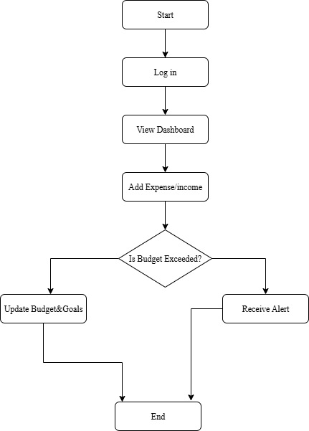
Figure 10: Flowchart Diagram
Figure 10 represents the flowchart of the Money Mate system, outlining the step-by-step process users follow when interacting with the application. The flow begins with the user either creating an account or securely logging in, ensuring only authorized access. Once inside, users can record their income and expenses through simple forms that categorize transactions for clarity. These records are then processed by the system, updating the user’s dashboard in real-time to reflect balances, savings goals, and budget progress. If spending exceeds the set limits, the system triggers alerts or notifications, guiding users back on track with their financial plans. The flowchart also includes decision points, such as whether the user wants to update records, set new goals, or generate reports. Each action loops back to the dashboard, providing a continuous cycle of tracking, monitoring, and adjusting. This structured flow ensures Money Mate delivers a smooth, user-friendly experience while keeping financial management simple and transparent.

5.2.4 Entity Relationship Diagram
An Entity Relationship Diagram (ERD) is a simple visual map that shows how data is organized and connected in a system. It identifies key entities, like users, expenses, income, and budgets, and shows the relationships between them. For example, a user creates expenses or sets budgets. In Money Mate, the ERD helps ensure the database is well-structured and easy to understand for both developers and stakeholders.

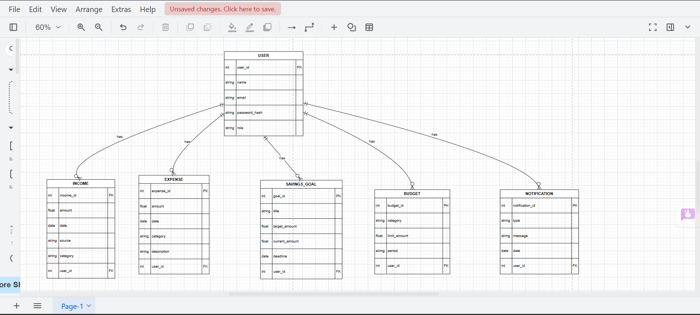
Figure 11: Entity Relationship Diagram
Figure 11 illustrates the Entity-Relationship Diagram (ERD) for Money Mate. The diagram visually maps out how different parts of the system relate to each other, with the User entity placed at the center. Since Money Mate is a personal finance management tool, every feature revolves around the user’s profile, which stores key details such as their name, email, and secure password hash.
From the User entity, there are direct relationships with five main components: Income, Expense, Savings Goal, Budget, and Notification. The Income entity keeps records of the user’s earnings, including the amount, date, source, and category. On the other hand, the Expense entity captures details of the user’s spending, such as amount, category, and description. These two entities work together to provide a clear overview of cash flow.
The Savings Goal entity is linked to the user to help track financial targets. It includes information such as the goal name, target amount, and current progress. Meanwhile, the Budget entity enables users to set spending limits across categories within a specific period, promoting disciplined financial habits. Finally, the notification entity supports reminders and alerts, such as when a user overspends or has an upcoming bill.
Overall, this ERD shows how Money Mate integrates income tracking, expense management, savings goals, budgeting, and notifications into one centralized system, all tied to the user. It emphasizes the logical structure of the database while ensuring scalability, security, and efficiency in managing personal finance.

5.2.5 Data Flow Diagram
Level 0

A Data Flow Diagram (DFD) is a simple visual tool that shows how information flows within a system. Instead of focusing on technical details, it gives a big-picture view of how data enters the system, how it gets processed, where it is stored, and how it moves between users, databases, and different parts of the system. In other words, a DFD helps us clearly understand the journey of data from start to finish, making it easier for both technical teams and non-technical stakeholders to see how the system works.
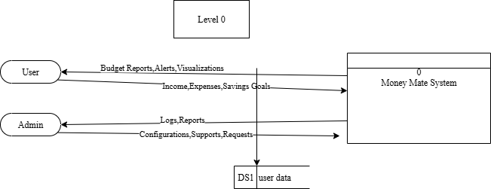
Figure 13: Level 0 Data Flow Diagram
Figure 13 illustrates the Level 0 Data Flow Diagram (DFD) of the Money Mate Budgeting System, providing a simple, high-level view of how data moves between users, administrators, and the system itself. The diagram shows that users interact directly with the Money Mate system by submitting data such as income, expenses, and savings goals. In return, the system processes this information and provides users with budget reports, alerts, and visualizations that help them better understand and manage their finances.
Administrators, on the other hand, handle configurations, support, and system maintenance tasks. They receive logs and reports from the system, allowing them to monitor performance and address any user issues. The single data store, labeled DS1 (User Data), acts as the central repository where all user-related financial information is securely stored and retrieved when needed.
Overall, this diagram captures the smooth interaction between the main actors users, admins, and the Money Mate system showing how data flows efficiently to support budgeting, reporting, and management processes in one integrated platform.
Level 1
A Level 1 Data Flow Diagram (DFD) provides a more detailed view of the system compared to the Level 0 diagram. It breaks down the main process into smaller sub-processes to show how specific functions handle data within the system. This level highlights how data moves between users, sub-processes, and data stores in a clearer way. It helps developers and stakeholders understand the internal workings of each major process in the system.
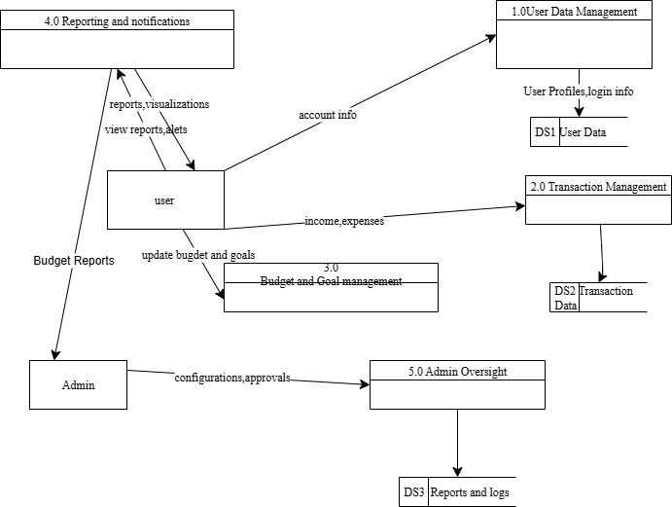
Figure 14: Level 1 Data Flow Diagram
Figure 14 represents the Level 1 Data Flow Diagram (DFD) of the Money Mate system, offering a deeper look into how data moves within the application’s core processes. The diagram breaks the system into several interconnected modules, including User Data Management, Transaction Management, Budget and Goal Management, Reporting and Notifications, and Admin Oversight.
In this diagram, the user interacts with multiple processes they can log in or update their profile through the User Data Management process, record their income and expenses under Transaction Management, and set or modify savings goals and budgets in Budget and Goal Management. The Reporting and Notifications process provides users with visual reports, insights, and alerts based on their financial data, helping them stay on track with their goals.
On the administrative side, the Admin Oversight module handles configurations, approvals, and monitors user activities through system reports and logs. Data stores such as User Data (DS1), Transaction Data (DS2), and Reports and Logs (DS3) ensure that all user and system information is stored securely and efficiently. Overall, this diagram highlights how Money Mate’s internal components work together to deliver a seamless and organized budgeting experience.
Level 2
A Level 2 Data Flow Diagram (DFD) gives a deeper look into one specific process from the Level 1 DFD, breaking it down into smaller, detailed sub-processes. It shows exactly how data moves within that process, including inputs, outputs, and interactions with data stores. In the context of Money Mate, it could, for example, detail how income and expenses are added, categorized, and updated within the transaction management system.
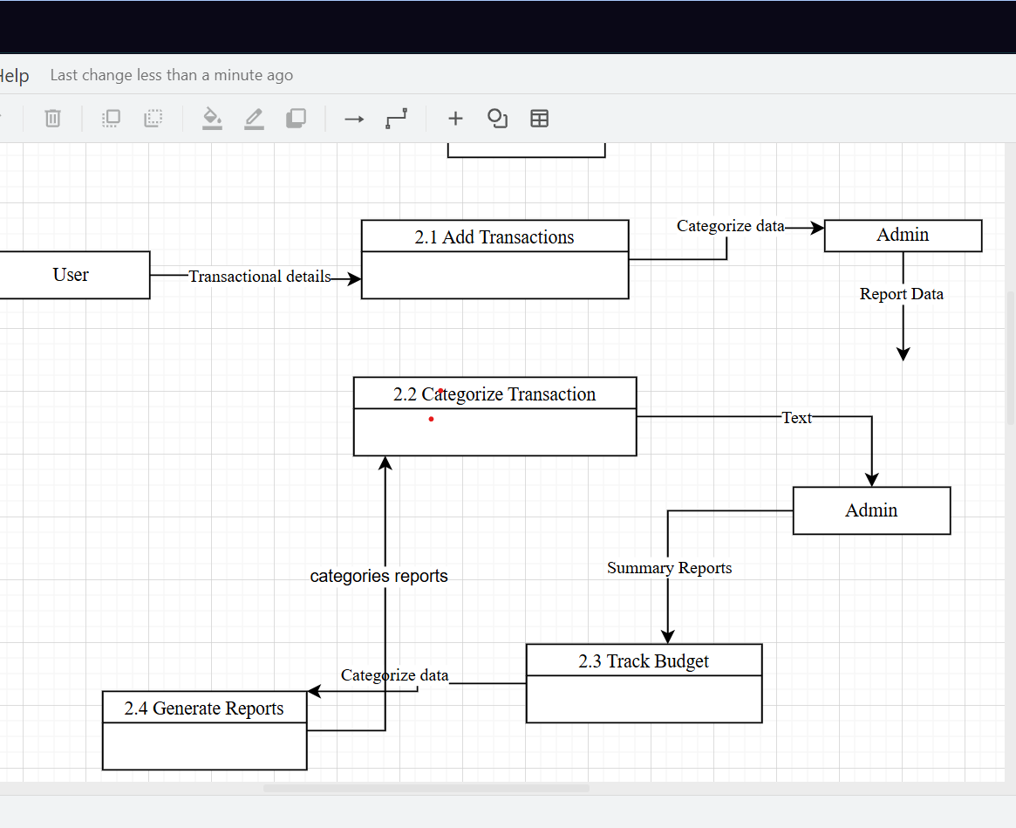

Figure 15: Level2 DFD

Figure 15 illustrates the workflow of how Money Mate helps users manage their finances, from entering transactions to generating meaningful reports. The process begins when a user adds their transaction details, which form the foundation of the system. These details are captured in the “Add Transactions” stage, where they are recorded and prepared for further organization. At this stage, the admin can also step in to help structure or analyze the data if needed.
The next step, “Categorize Transactions,” ensures that all entries are sorted into clear and meaningful categories. This organization makes it much easier to understand spending habits and analyze financial patterns. The admin may also provide input here, refining the categorization to make the data even more accurate and insightful. Once categorized, the system moves into the “Track Budget” stage, where users receive summaries that highlight how well they are sticking to their budgets and whether they’re approaching or exceeding their limits.
Finally, the workflow ends with “Generate Reports.” At this point, Money Mate compiles all the processed and categorized data into detailed reports. These reports give both the user and the admin a complete overview of financial activity, offering valuable insights for smarter decision-making. Overall, this workflow demonstrates how Money Mate combines user input, admin support, and system automation to make financial management easier, clearer, and more effective.
5.2.6 Class Diagram
A class diagram is a type of UML diagram that shows the structure of a system by illustrating its classes, attributes, and relationships. It focuses on the blueprint of the system, describing how different parts of the application connect and interact.
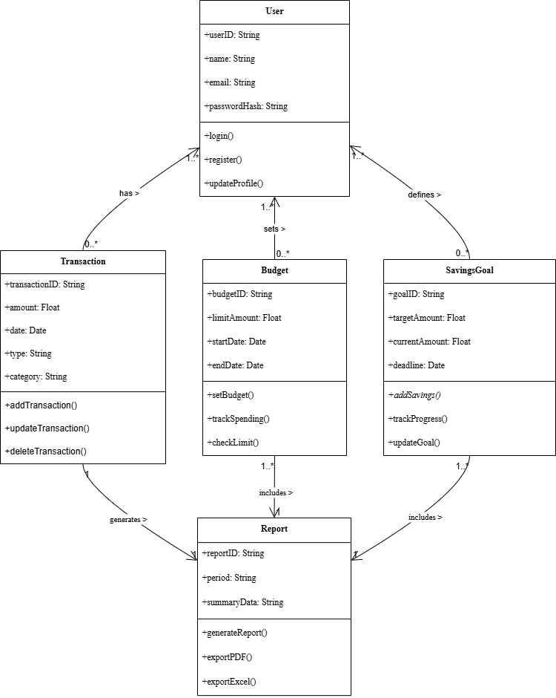
Figure 16: Class Diagram
Figure 16 represents a class diagram that shows how the main parts of the Money Mate system are connected and work together. At the center is the User, who is the core of the system. The User has basic details like ID, name, email, and password, and can perform actions such as logging in, registering, or updating their profile. From there, the User interacts with different features of the system, including transactions, budgets, savings goals, and reports.
The Transaction class is responsible for handling all financial activities. Each transaction has details like an ID, amount, date, type, and category, and users can add, edit, or delete their transactions. Since users may record many financial activities, there is a “many” relationships between the User and Transactions.
The Budget class lets users set limits on their spending. It includes details such as the budget amount, start and end dates, and comes with methods that help track spending and check whether the user is within their set limit. Similarly, the Savings Goal class helps users set targets for saving, like reaching a specific amount by a certain date. Users can add savings, track their progress, and adjust their goals whenever needed.
Finally, the Report class generates summaries of all financial activity. Reports can be created for different periods and exported in formats such as PDF or Excel. These reports pull together data from transactions, budgets, and savings goals, giving users a clear overview of their financial habits.

5.2.7 Activity Diagram
An activity diagram visually shows how different actions or processes flow within a system. It outlines the sequence of steps, decision points, and possible parallel activities from start to finish. This helps illustrate how the system behaves and how users interact with it over time, making it a useful tool for understanding and improving workflows.
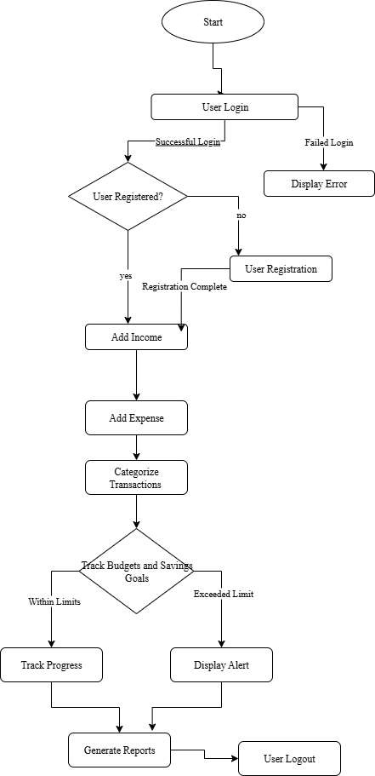
Figure 17: Activity Diagram
Figure 17 illustrates the user workflow in the Money Mate personal finance management system. The process begins when a user logs into the platform. If login credentials are incorrect, the system displays an error message, while new users are directed to a quick registration process before continuing. Once logged in, users can input their income, record expenses, and categorize these transactions creating the foundation for effective financial tracking and management.
After transactions are categorized, the system automatically evaluates whether the user’s spending aligns with their set budgets and savings goals. If spending remains within limits, users can track their progress and move on to generate detailed financial reports. However, if overspending occurs, the system issues a friendly alert before proceeding to report generation. The workflow concludes with the user logging out, ensuring that all data is securely saved. Overall, this flowchart highlights a smooth and logical process that helps users stay on top of their finances, offering real-time insights and guidance at every step.

5.2.8 Sequence Diagram
A sequence diagram is a type of Unified Modelling Language (UML) diagram used in software engineering to visually represent how objects or components within a system interact with one another over time. It depicts the order and flow of messages or events exchanged between different participants (called lifelines), showing how processes collaborate to achieve a specific task. The diagram uses vertical lines to represent the lifecycle of objects and horizontal arrows to show the communication or interaction between them.
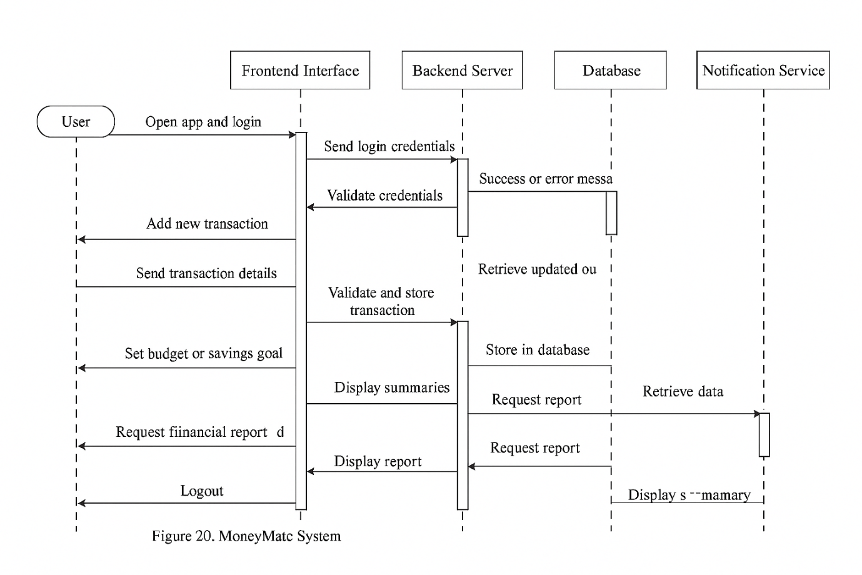
Figure 18: Sequence Diagram
Figure 18 represents a sequence diagram that shows how different parts of the Money Mate system work together to help users manage their finances. The process starts when the user logs in through the app’s interface. The login details are sent to the backend, which checks the database to confirm if the credentials are correct. Once verified, the user gains access to their dashboard and can perform various actions like adding transactions, setting budgets, or viewing reports.
When a user adds a transaction, the backend saves the data in the database, and the updated information is instantly reflected on the user’s dashboard. If the user sets a budget and later overspends, the system automatically uses the notification service to send an alert, helping them stay within their financial limits. The user can also generate reports, which the backend compiles from stored data and displays neatly through the frontend. Finally, the session ends when the user logs out, ensuring data security. Overall, this diagram captures how Money Mate’s components the user interface, backend, database, and notifications interact smoothly to provide a seamless and responsive financial tracking experience.

5.2.9 Wireframe Diagram
A wireframe diagram is like the blueprint of a website or app it lays out the basic structure and flow before any colours, images, or fancy design elements are added. It shows where key components such as buttons, menus, images, and text will go, giving a clear sense of how users will interact with the system. Instead of focusing on visuals, a wireframe highlights functionality and navigation, helping designers and developers plan a smooth user experience from the start. In short, it’s a practical guide that ensures everything works logically before moving on to the creative stage.

Homepage
A homepage is the main entry point of a website the first page visitors see when they access the site. It acts as a welcoming introduction, giving users a clear idea of what the website offers and helping them navigate to other sections through links or menus. A well-designed homepage makes a strong first impression, captures attention, and encourages users to explore further by showcasing key features, services, or updates in an engaging and organized way.
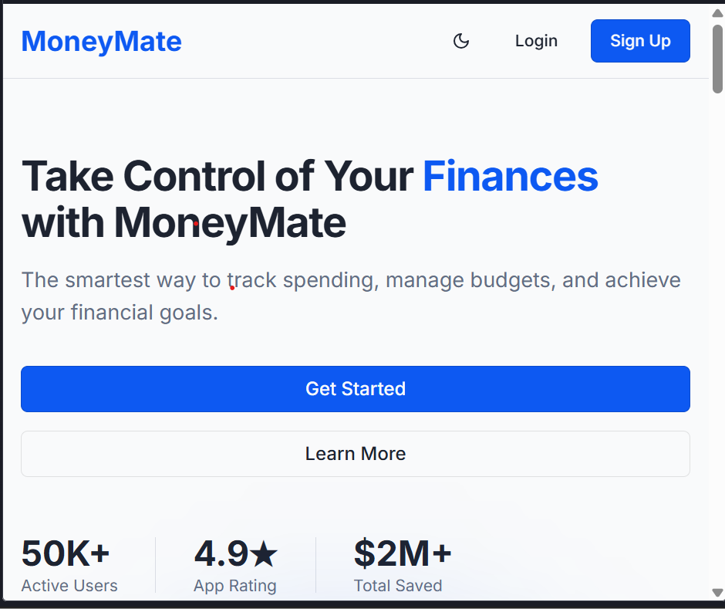
Figure 19: Homepage Wireframe
Figure 19 illustrates the landing page of the Money Mate web application, designed to introduce users to the platform and encourage them to sign up or log in. At the top, the page features the Money Mate logo and a clean navigation bar with options to log in or sign up, promoting easy access for both new and returning users. The central section prominently displays the tagline, “Take Control of Your Finances with Money Mate,” clearly communicating the app’s purpose helping users track spending, manage budgets, and achieve financial goals.
Beneath the tagline, a “Get Started” button provides a direct call to action, guiding new users toward creating an account, while a secondary “Learn More” button offers additional information about the platform. The lower part of the page highlights key statistics, such as 50K+ active users, a 4.9-star app rating, and $2M+ total saved, reinforcing the app’s credibility and success. Overall, the layout is simple, professional, and user-focused, using a modern design to inspire trust and motivate users to begin their financial journey with Money Mate.
Login page
A login page is a section of a website or app where users enter their details like an email or username and password to access their personal accounts. It serves as a secure gateway, ensuring that only authorized users can reach protected areas or sensitive information. Beyond just access, the login page plays a key role in maintaining privacy and safeguarding user data, making it an essential part of any secure digital platform.
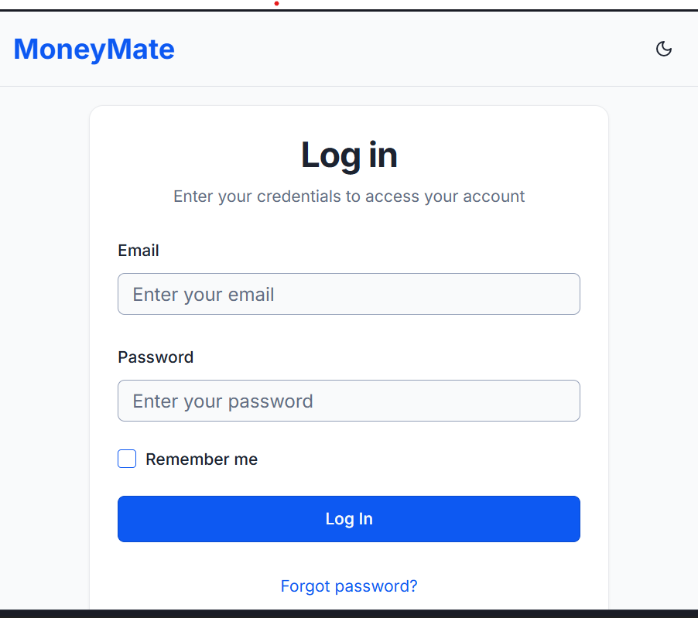
Figure 20: Login page

Figure 20 represents the login page interface of the Money Mate web application, designed to provide users with secure access to their personal accounts. The layout includes input fields for the user’s email and password, allowing them to authenticate their credentials before entering the system. A “Remember me” checkbox is available for users who wish to stay logged in on their device for convenience. The prominent Log In button initiates the authentication process, while a Forgot password? link offers users an easy way to recover their account if they cannot recall their credentials. Overall, this page emphasizes simplicity, accessibility, and security, ensuring a smooth and trustworthy login experience for all users.

Sign Up page
A sign-up page is a web page designed to let new users create an account so they can access a website, app, or online service. It typically includes a form where users fill in basic details like their name, email, and password. Many sign-up pages also include helpful features such as password strength indicators, checkboxes for agreeing to terms and conditions, and options to register using social media accounts. Once the registration is complete, users often receive a confirmation message or email to verify their account.
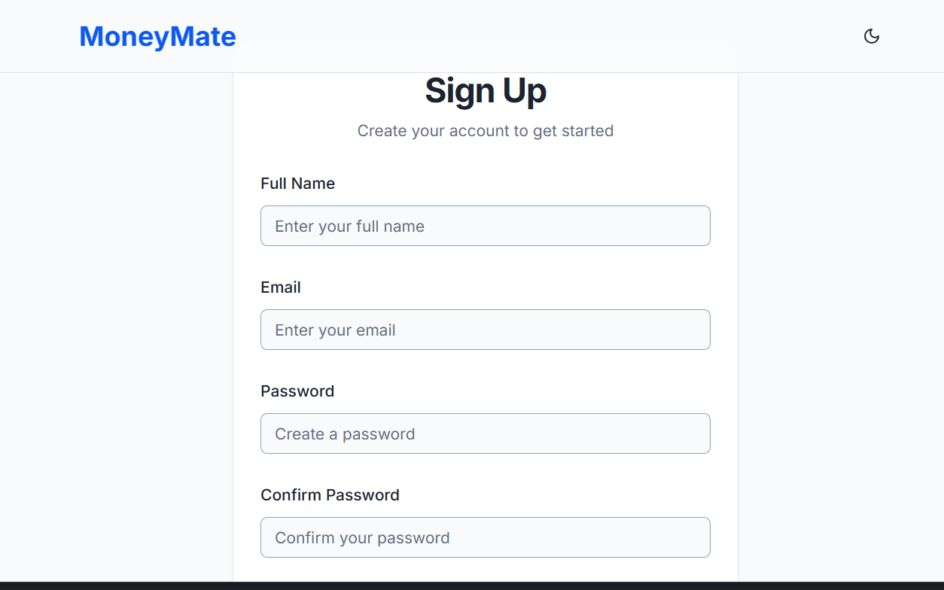
Figure 21: Sign Up Page
Figure 21 illustrates the sign-up page for the Money Mate system, which allows new users to create an account and access the platform’s financial management features. The page includes simple input fields for the user’s full name, email, password, and password confirmation to ensure accurate registration. Its clean and user-friendly design helps users easily navigate the registration process, reducing errors and making onboarding smooth. The layout emphasizes clarity and accessibility, ensuring that anyone whether a first-time user or a returning visitor can quickly complete the sign-up process and start using Money Mate’s budgeting and expense tracking tools.
Dashboard
A dashboard is a visual interface that displays key information and data in a clear, organized way usually using charts, graphs, and summaries. It gives users a quick overview of important metrics, trends, or activities, helping them monitor progress and make informed decisions. In apps like Money Mate, the dashboard shows financial summaries such as income, expenses, savings goals, and overall balance, allowing users to easily track and manage their finances in one place.
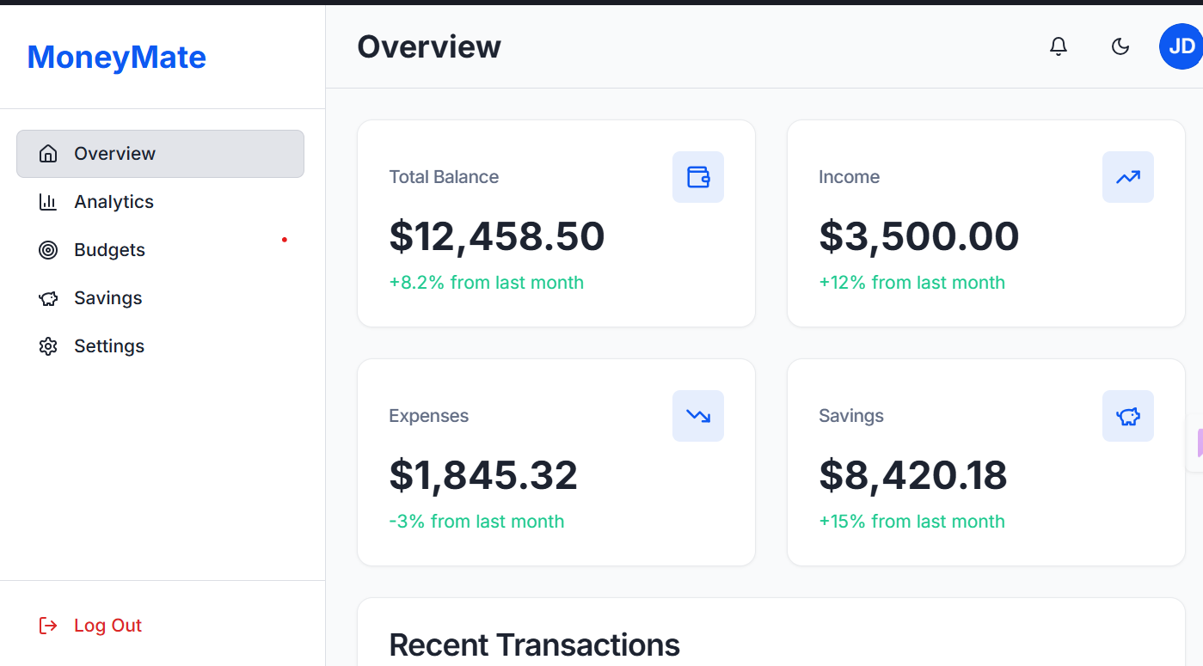
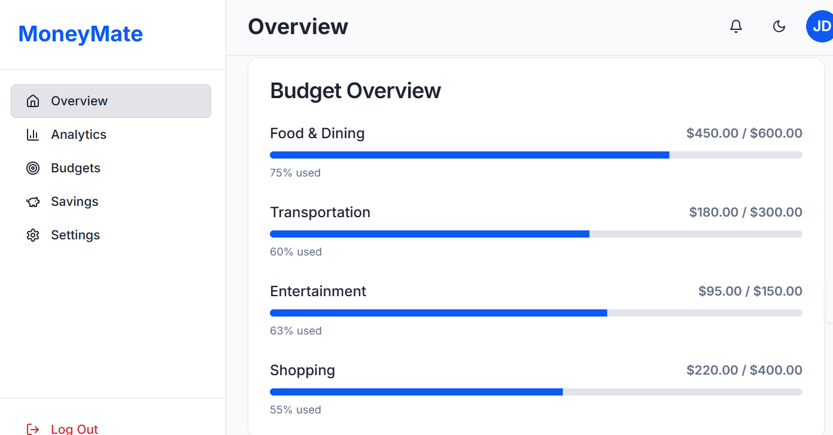
Figure 22: Dashboard
Figure 22 illustrates the main dashboard of Money Mate, a financial management web application that gives users a clear snapshot of their financial status. The dashboard displays key financial summaries, including a total balance of $12,458.50, showing an 8.2% increase from the previous month. It also presents an income of $3,500.00 (a 12% rise from last month), expenses of $1,845.32 (a 3% decrease), and savings totalling $8,420.18, which reflect a 15% improvement. On the left side, users can easily navigate through sections such as Overview, Analytics, Budgets, Savings, and Settings. Additionally, the bottom section of the dashboard highlights recent transactions, giving users a quick view of their most recent financial activities.
Also it displays the Budget Overview section of the Money Mate app, showing the user's spending progress against set budgets in four categories. For Food & Dining, $450 has been spent out of a $600 budget (75% used). In Transportation, $180 has been used from a $300 budget (60% used). Entertainment expenses are at $95 out of $150 budget (63% used), and Shopping is at $220 out of $400 budget (55% used). The progress bars visually indicate how much of each budget has been utilized, helping the user keep track of their spending across these categories.

References
Abraham, R., & Nair, S. (2023). Design and development of a personal finance management application. International Journal of Computer Applications, 185(32), 25–32. https://doi.org/10.5120/ijca2023927895
Bank, T. (2022). The role of digital tools in improving personal financial literacy and budgeting. World Bank Group Publications. https://www.worldbank.org/
Intuit Inc. (2024). Mint: Budget tracker and planner. Retrieved from https://mint.intuit.com
Spendee a.s. (2024). Spendee – Budget and expense tracker app. Retrieved from https://www.spendee.com
Mobills Labs. (2024). Mobills – Personal finance and budget planner. Retrieved from https://www.mobillsapp.com
Njoroge, P., & Mwangi, E. (2023). Adoption of financial management systems among young adults in Kenya. African Journal of Information Systems, 15(2), 89–104.
Google Firebase. (2024). Firebase documentation: Build secure and scalable apps. Retrieved from https://firebase.google.com/docs
MongoDB Inc. (2024). MongoDB for developers: Data modeling and scalability. Retrieved from https://www.mongodb.com
ReactJS Foundation. (2024). React documentation: Building interactive user interfaces. Retrieved from https://react.dev
Microsoft Azure. (2024). Cloud hosting and deployment for modern web applications. Retrieved from https://azure.microsoft.com

